Detail Design
Textfyre, Inc
Copyright © 2007 – All Rights Reserved
World: Orphan
Series: Orphan, Princess, and Queen
Episode: Orphan

Team:
Original Design: David Cornelson
Writers: Michael Gentry
Programmers: David Cornelson
First Draft Testers:
Alpha Testers:
Beta Testers:
Finalization Testers:
Editors: Fahmida Cater, Bob Feest, Bill Kolomyjec
Graphic Artist: Erika Richardson
Flash Artist:
Modification History
Who | When | What
David Cornelson | 30-Nov-2006 | Original Outline Draft
David Cornelson | 21-Dec-2006 | Cleaned up per Mike Gentry’s comments
David Cornelson | 02-Jan-2007 | Detailed world elements
David Cornelson | 04-Jan-2007 | Updated Synopsis
David Cornelson | 10-Feb-2007 | First Draft of Scene I
David Cornelson | 14-Feb-2007 | Scene II Design – Commerce Street
David Cornelson | 17-Feb-2007 | Finalized synopsis and added outline headings. Added Chapter II design. Started Chapter III.
David Cornelson | 7-Mar-2007 | Incorporated Chapter I from Mike Gentry’s submission. Added maps for all chapters.
Mike Gentry | 8-Mar-2007 | Incorporated rest of Chapter 1; fixed outline structure for clarity, consistency; added part of Chapter 2
Mike Gentry | 14-Mar-2007 | Added room and NPC descriptions for Chapter 2; aligned the tabs on the cover sheet because it was driving me crazy
David Cornelson | 7-Apr-2007 | Dialogue table for Chapter 2 added.
David Cornelson | 14-Apr-2007 | More Dialogue for Chapter 2.
Michael Gentry | 12-May-2007 | Room descriptions through Chapter IV, design notes.
Michael Gentry | 16-May-2007 | Dialogue

Table of Contents
Detail Design 1
Map of Miradan 8
The World of Orphan 9
The People 9
Ascension 9
Magic 9
In People 9
In Things 10
Physics 10
Astronomy 10
Recent History 10
Before The Story Begins… 12
Royalty Reference 13
The Players 14
The Player Character 14
Jacqueline Toresal (aka Jack) 14
Major Non-Playing Characters 14
Bobby 14
Baron Fossville (aka The Baron, Fossville, the Dark Hunter) 14
Mercenaries (group of men) 14
Hester Rodop (aka the Magistrate) 14
Jacobs 14
Olmer 14
Darens 14
Other Major Characters 14
Duke William Toresal (aka Lord of the Keep, the Old Lord, the Prince, the Queen’s Son) 14
Minor Non-Playing Characters 15
Teisha 15
Angeline, Clara, Fiona, Theresa, Shannon (Maiden House) 15
Germaise (In Bakery) 15
Old man Holstenoffer (In Butchery) 15
Olgan Minor (Armory) 15
Mrs. Sandler (Jewelry) 15
Pieter (Jewelry) 15
Rudolph (Jewelry) 15
Chorus Brothers 16
The Screenplay 17
SYNOPSIS 17
Game Features 19
Time Keeping 19
Details 20
Chapter I – Grubber’s Market 20
Map 20
Rundown 20
Notes 21
Design 21
Chapter II – Commerce Street 38
Map 38
Rundown 38
Notes 38
Design 38
Chapter III – Bobby 56
Map 56
Rundown 56
Notes 57
Design 57
Chapter IV – Maiden House 63
Map 63
Rundown 63
Notes 63
Design 63
Chapter V – Captured 66
Map 66
Rundown 66
Notes 66
Design 66
Chapter VI – Underground 68
Map 68
Rundown 68
Notes 68
Design 68
Chapter VII – Black Gate Estate 69
Map I - Rooftops 69
Map II – Black Gate Estate 69
Rundown 69
Notes 69
Design 70
Chapter VIII – Maiden House II 71
Map 71
Rundown 71
Notes 71
Design 71
Chapter IX – Red Gate Estate 72
Map 72
Rundown 72
Notes 72
Design 72
Chapter X – Pieter 73
Map 73
Rundown 73
Notes 74
Design 74
Chapter XI – Mercenaries 75
Map 75
Rundown 75
Notes 75
Design 75
Chapter XII – The Baron 76
Map 76
Rundown 76
Notes 76
Design 76
Chapter XIII – The War Room 77
Map 77
Rundown 77
Notes 77
Design 77
Chapter VIX – The Princess 78
Map 78
Rundown 78
Notes 78
Design 78

Map of Miradan
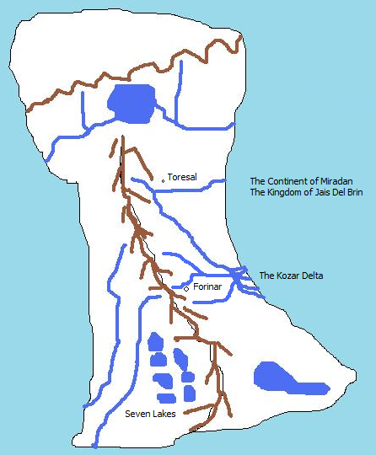

The World of Orphan
In this world there exists a single planet where humans live and magic is extremely rare. The world has large bodies of water and at least one land mass as of this history. This continent is known as Miradan and is loosely ruled by the Kingdom of Jais Del Brin.

The People
The people of Jais Del Brin are generally farmers, fisherman, and townspeople. Commerce is rugged and local, and the Kingdom generally functions without much taxation. Royalty includes the King and Queen, Princes, Princesses, Dukes and Duchesses, Earls and Countess, Barons and Baronesses.

Ascension
The Kingdom generally selects new Kings based bloodlines, but this is married to the fact that the vast majority of Kings have sired strong, popular, and healthy sons to ascend to the throne. The key here is popularity. The Kingdom has rarely had to think about succession and when it has, it has generally been between two strong choices, not a complete lack of strong choices.
In the absence of a strong and popular blood prince, the laws of the Kingdom state that the King or Queen must choose a successor. In the event of the death of the King and the Queen before a successor has been named, all of the primary royals will select a Regent to handle Kingdom affairs until a successor is selected by vote. Voting is weighted in that Princes and Princesses get ten votes, Dukes and Duchesses get five votes, Earls and Countesses get three votes, and Barons and Baronesses get a single vote. But again, the general public’s opinion is taken into consideration before a successor is selected. A special People’s Regent role has always been filled, but never used but for ceremony. The role in the case of an unclear successor is to poll the people and make known their wishes. Obviously, in certain circumstances, this could become a very dangerous and powerful role.

Magic

In People
Magic is known to exist and is treated respectfully by the general population. They consider it either lucky or unlucky to have good or bad things happen due to magic respectively. Everyone always dreams of some minor magic to help their daily lives, but almost no one goes in search of it. Life is hard and there is no time for such endeavors. Those people that have discovered a talent for magic generally keep it to themselves and help or hurt those as they would with any other talent. There is no general commerce in magic, but if a magic user is available, some may intrude to ask for a favor and offer some token in return. Magic tends to develop in women more than men, although an analysis of those with “talent” would show that girls are encouraged to look within and boys are not, so never develop whatever ability they may have. Girls with talent are considered blessed or cursed, depending upon their nature (if a girl is a trouble-maker, she’s cursed…if a girl is kind, she is considered blessed).
Most magic is minor. Very little “grand magic” is know about or has ever been seen. The common uses of magic are to mend clothes, cure minor ailments, fix broken tools, and the like. On occasion a magic user will have more interesting abilities.

In Things
There are artifacts that are imbued with magical ability, giving the owner of the artifact some magical ability, albeit focused and limited.

Physics
The general physics of this world are the same as Earth.

Astronomy
The night sky of this world is full of stars. One section of the sky that is seen in summer is a strip of very bright stars known commonly as “The River of Light”. It also has two moons, one noticeably large than the other. They are known commonly as Big Sister and Little Brother.

Recent History
The Realtic Kingdom has been seemingly healthy for hundreds of years, with successions going without any problem. But the last two kings have ruled poorly and the most recent king has left the land to an elderly queen, who only late in life realized she would need to rule and determine a successor. Although her children and grandchildren may vie for the crown, their particular fates have produced a great deal of concern from the public and the Lord’s council as to their ability to rule.
Succession rights are simple where blood is concerned, but with so many inline, the fate of the kingdom is not so simply decided. It’s almost a game or a sport. Whoever shows the Queen that they deserve it, and then garners public approval, will become the heir to the throne. Because the Kingdom has had such a peaceful history, the public would balk at a heavy-handed ruler.
Orphan is the story of a young girl that is at the top of the blood lines, along with many other potential successors. Her father was the last son born of the current queen, with seven siblings in front of him. Unfortunately, his fate was decided by Baron Fossville. Having seen the coming turmoil, he wished to vie for the thrown himself, and turned to dark means to attain it.
In the 756th year of the Kingdom, Baron Fossville managed to slowly poison Duke Toresal, making it look like a mysterious illness. What Fossville did not know until taking over the Duke’s keep and lands was that the former Lord had bore a child with a woman in secrecy. Since the Duke was already married, the secret remained buried for years. But before his death, Duke Toresal left written claim to all of his estates to his only daughter. He had loved the woman that bore her, but could not openly recognize her or their child…a mandate from the Queen herself, since the woman was not of royal blood.
But his will left the door open for young Jacqueline, and this is her story….

Before The Story Begins…
Your name is Jacqueline, but everyone outside of the Maiden House knows you as Jack. A few people have come to know you well enough to know that you are a girl and some have figured it out on their own. A few suspect that you are special and some think it's because you are the daughter of a royal personage. No one knows for sure. There is proof of the matter within your father’s personal papers and some people in the royal government know. The fact that you exist and there is no other clear heir to the local lands (much less the Kingdom’s throne) is the intrigue into which you were born. If you were to be recognized a royal heir it would cause a great deal of upheaval and if you were not recognized, things would probably progress more smoothly, albeit in a fashion the crown is not comfortable with. It would elevate a family that is highly ambitious, placing their heirs in a position to marry into the throne.
Your sponsor has in fact been your father by blood. He loved the woman that bore you to him, but as a mistress, there was no way to bring her or you to court. For the first ten years of your life, your father watched as you grew. He made sure that some of the women in Maiden House were well-educated and paid them to tutor you.
In your eleventh year, Lord Duke Toresal died of a mysterious illness. He left a legacy of goodwill among the people, but the succession to his lands was clearly going to Baron Fossville, a man who hired mercenaries for mysterious businesses and who had clear ambitions for the royal court. Fossville’s machinations were coming to fruition as a royal ball was planned at which he would be betrothed to one of the Queen’s daughters.
You are a fourteen year old girl on the verge of becoming a woman. Your mother died when you were born and you do not know who your father was. You do know that someone sponsored your early upbringing at Maiden House. Even though they care for you and feed you, and even though you do appreciate everything they did, you always felt you were destined for something else. You learned to read and write; a great deal of history of the land, to speak and act properly, and how to be respectful. You even were given the gift of a solid self-esteem. You possess all of the things that most orphans never even know about.
Eventually you decide that the stodgy lifestyle of the Maiden House was more than you can bear and you began taking to the streets at the age of eleven, nearly the same time Lord Toresal died. Wearing trousers and a boy’s shirt and continually cutting your hair off with a blade and covering it with a hat, you instinctively realized that certain doors were open to you pretending to be a boy.
The maidens counted it a phase and although they worried if you were out all night, they never questioned where you'd been or what you'd done. It was as if they accepted your maturity and decision making almost entirely without question. But they did look out for you too. More than once you caught one of the younger maidens "accidentally" bumping into you.
For the next three years you manage to befriend other orphans, although of less luck. They happily show you how to beg, steal, and sneak around town without ever getting caught by the magistrate or his soldiers. One of the beggars you befriend is a boy named Bobby, who appeared on the streets shortly after your eleventh birthday. Never questioning the appearance or disappearance of any of the orphans, you don’t realize that he is in fact a spy for the royal court, and in some ways, your protector.

Royalty Reference
King, Queen
Prince, Princess
Duke, Duchess
Prince, Princess (if they have royal parentage)
Earl, Countess
Baron, Baroness

The Players

The Player Character

Jacqueline Toresal (aka Jack)
Jacqueline is a fourteen year old girl coming of age in a rugged town on the outskirts of the Kingdom.

Major Non-Playing Characters

Bobby
Bobby is an orphan, sixteen years old, and seems to do things for various people for money, but you can never quite figure out what he does. You don't know where he sleeps, but he always seems "taken care of". Well, sometimes he looks a wreck, but he never seems bothered by it.

Baron Fossville (aka The Baron, Fossville, the Dark Hunter)
Baron Fossville is a nobleman by birth, the son of some cousin of the royal family. He’s been sent on many a mission for the crown to deal with uprisings and skirmishes with the western people. Through these efforts he has gained a formidable following. It is commonly believed that he is maneuvering to marry the eldest daughter of the Queen and become heir to the throne.

Mercenaries (group of men)
The mercenaries are generic men with tunics, pants, swords, helms. They all speak in broken language laced with common slurs. They aren’t very smart either.

Hester Rodop (aka the Magistrate)
The magistrate, Hester Rodop, is a very bad man. He will try very hard to catch you doing something wrong and if he does, it will not go well for you. You could wind up in a cell with bad men.

Jacobs
Jacob’s is the son of a wealthy merchant. He’s a big brutish man. Though he is slightly insane, he will talk about anything to anyone.

Olmer
Olmer is a typical town bum. On some days he’ll work and some days he’ll steal. He’s never seen without Darens.

Darens
Darens is another typical bum. He’s always with Olmer.

Other Major Characters

Duke William Toresal (aka Lord of the Keep, the Old Lord, the Prince, the Queen’s Son)
Lord Toresal ruled the namesake lands for several decades in peace and prosperity. The keep was always open to commoners and the town was built to provide a place for commerce. Everyone seemingly benefited from the prince’s rule, except for Baron Fossville. Toresal kept Fossville at arm’s length for some unknown reason and two were known to have verbal jousts in public.

Minor Non-Playing Characters

Teisha
Teisha is a girl in Grubber’s market that is somewhat of a friend. She teases about the Maiden House and is somewhat aloof, but she is never mean to you. Although there is no blood relationship, the two of you look somewhat alike, if not a perfect match.

Angeline, Clara, Fiona, Theresa, Shannon (Maiden House)
Angeline, Clara, Fiona, Theresa, and Shannon are the women in the Maiden House. They are all widows that look out for each other. They do various odd jobs for town folk and farmers who pay them in food and bare necessities. They know many things about the town and surrounding area, although they will very rarely offer details without some prior knowledge.
These women are the help system. They will offer information on how to solve problems within the game as you learn about them. So when you find a door you can't unlock (unlikely), they will know how to help you.
All of the women will occasionally be caught gossiping about town drama.
Table of Dramatic Topics
Crown Politics/Ascension/Queen
Grubber’s Market
Lord’s Market
Commerce Street
Jacob’s
Eligible Bachelors
Jack
Lord Toresal
The Ball (when announced)
Baron Fossville
The Princess
Each Other

Angeline – Widow, looking for new husband. Plump and pleasant. Not generally an ugly person.
Clara – Widow, looking for a new husband. Skinny and Uptight. Despite her personality faults, not an ugly person.
Fiona – A Royal Instructor assigned to Jack by Lord Toresal. This relationship is not known about by the crown. Probably had some close relationship to Lord Toresal before he died. Fiona tutors Jack in Jack’s room.
Theresa – Widow of a previously wealthy man who was so far in debt that he left her with nothing. She does not like Jack because Jack has been “spoiled” from birth compared to the rest of the orphans. She is very suspicious and will lie about everything Jack asks about.
Shannon – Plain and not interested in marriage. She loves taking care of the orphans. Loves to cook, clean, and help in the Maiden house. She isn’t very bright. She’s in charge of the toddlers.

Germaise (In Bakery)
Germaise is a big gossip who harmlessly eyes young women despite being married.

Old man Holstenoffer (In Butchery)
The butcher, an affable man, will talk incessantly while you are in his shop. Some of the things he says will give you some clues to puzzles.

Olgan Minor (Armory)
Olgan, a very serious man, will talk about Fossville’s recent purchases of armor, as if he plans to build an army. Olgan see the world through darker eyes and anything important that you say will get back to the Baron.

Mrs. Sandler (Jewelry)
As it turns out, Mrs. Sandler knows who your mother was and liked her. She also is in possession of something that belongs to you; a diamond and ruby necklace.

Pieter (Jewelry)
Pieter is also a spy for the crown, but plays a guard. He knows all about you.

Rudolph (Jewelry)
Rudolph is a simpleton guard, and friend of Pieter’s.

Chorus Brothers
When rumors start floating about your possible inheritance, the Chorus brothers are more than willing to lend you money, considering it an excellent investment.

The Screenplay

SYNOPSIS
A young orphan girl pretending to be a boy discovers people are trying to kill her, that she is royal born, and that she must save herself by finding out as much information as possible, as well as proving that she is worthy of being recognized as the heir to the local lands.
- Jack is chased by mercenaries and does not know why.
- Jack has opportunities to talk to people about the environment. (Butcher, Baker, Armory, Moneylender, Jeweler, Clothier)
- Jack meets Bobby.
- Jack goes back to town to sleep at Maiden House, where the women hide her in a secret room. Here she learns about her mother.
- Bobby takes you Lord’s Keep. They find about the Queen’s visit and the upcoming ball where the Baron will marry into the Royal Family.
- Jack tries to get back through town to the woods and is captured. Bobby is beaten up badly in an adjacent cell. He whispers about secrets in Black Gate Estate, the in-town residence of Baron Fossville. Jack meets crooks that help her escape and tell her where to hide in the sewer.
- Jack is chased into sewer system and hides in Maiden House.
- Jack comes out of hiding and gets into Black Gate Estate. She finds out about her father, including the letter that recognizes her as heir.
- Jack hears that Bobby has been hung and returns to Maiden House. The women open up about everything and tell her that the Red Gate Estate (previously her father’s residence) is her home now, but dangerous to go there.
- Jack gets into Red Gate Estate with key from maidens and one of the maidens coming with her. She finds artifacts about her father. She also finds fresh clothes and a bath. One of the maidens helps her bath and suggests she buy a new gown and to sneak into the ball to seek audience with the Queen.
- Jack visits the moneylender and with the letter is able to take money out. Jack visits the clothier and jeweler to get ready for ball. Pieter decides to accompany her. Jack visits the armory and buys a stiletto knife and hides it in her bodice.
- Jack and Pieter cannot enter Lord’s Keep directly as the mercenaries are all stalling guard.Jack shows Pieter the secret entrance. On their way through the woods, an odd old woman approaches them. She cryptically offers Jack a potion. The potion makes Jack’s hair grow out. They enter the Keep and filter into the ball room, uninvited. The Queen has not arrived yet.
- The mercenaries start filtering into the Keep. They begin to recognize Jack and Pieter disappears.The Baron appears at Jack’s side and holds her arm tightly. He walks her to the War Room.
- Jack enters the War Room. Pieter is slumped on the floor, bound hand and foot. Several mercenaries glare at Jack menacingly. The Baron has the door guarded and sits down. He asks Jack what you’re doing. Jack shows him the letter. He seems nervous, but confident. The Baron burns the letter in the fireplace and picks up his sword. He approaches. Suddenly there is an argument outside. A fight is heard.The door is knocked down and Bobby comes charging in. He fights a dual with the Baron.
- Jack releases Pieter with your knife. He takes it and begins fighting mercenaries. The Baron knocks Bobby down and runs out of the room. The mercenaries follow, as do Pieter and Bobby.The Princess comes into the room from a secret passage. She has more mercenaries with her and they kidnap Jack.

Game Features

Time Keeping
The setting must have night and day characteristics.
Room locations should note light regarding the sun and moon where appropriate.
Room locations should note crowdedness based on the time of day. For instance, the markets are crowded during the day and empty at night.
We should be able to easily enough implement "wait for darkness" or "wait until morning". This could potentially be an extension.

Details

Chapter I – Grubber’s Market

Map
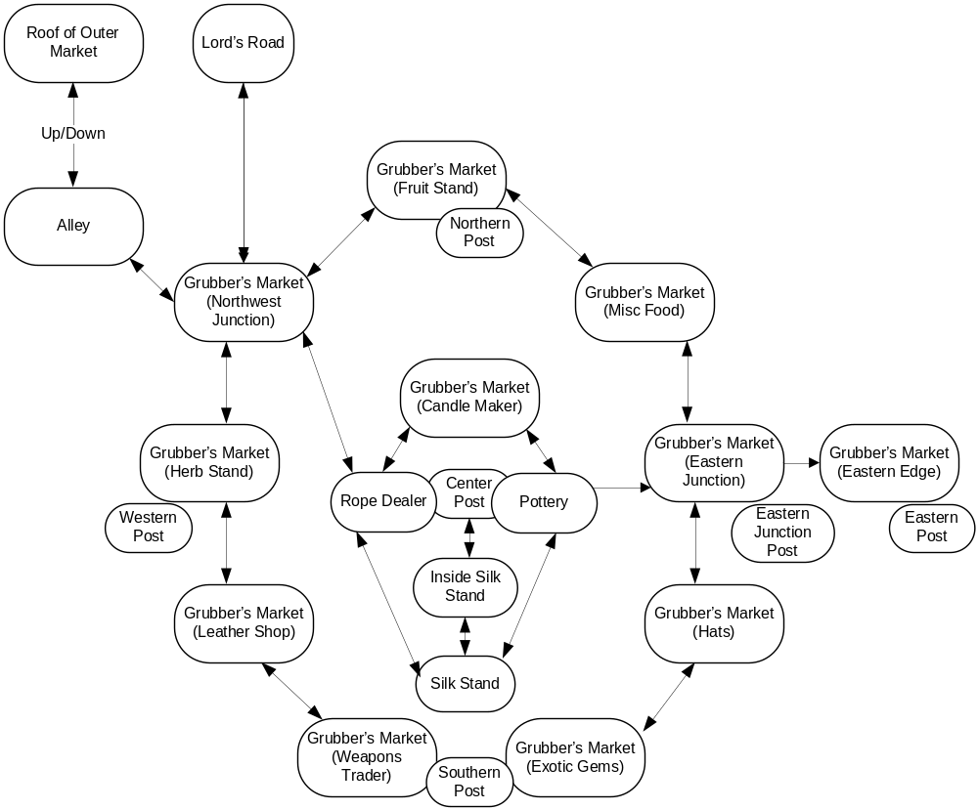

Rundown
You have no money. You are wearing a wool cloak. You have an apple.
You may steal a knife from a mercenary.
You may trade the knife for nearly anything in the market including herbs, fruit, candles, rope, pottery, silk, belt, boots, coin, small gem, or a hat. You will always be able to steal another knife, but never hold more than one at a time.
The monkey wants a banana.
The monkey has a necklace and will trade for a banana.
The monkey runs across the postal wires all the time. If you’re at the Exotic Gems stall, he will come down to its roof and taunt you with the necklace.
Teisha, in the silk stall, will give you a silk cloak for the necklace.
You can get a hat by trading your cloak.
You can get a belt by trading a hat.
You can get fruit with coin.
You can never go east to the Eastern Edge or you will be caught and have to escape back to the west.
You can go up the center post and slide down to any of the outer posts.
When you slide down, the guards will see you. You should not be wearing the cloak yet.
When you go down from the n, w, or s post, you should wear the cloak and undo your hair so that you look like a girl.
Now you can leave the market before the men recognize you.

Notes
Should the monkey be able to block you from sliding down? If so, how should we get rid of the monkey? This _has_ to be a funny response. I can just feel it.
If you simply turn into a girl and start walking directly out of the market, the mercenaries at the eastern edge are so loose that they’re pretty much accosting everyone and will catch you. In order to get past them, they must be on edge from seeing you traverse the wire from the center post.

Design
- Introduction
  - Scene [before play begins]: Mid-morning always sees the Grubber's Market at its most crowded. Servants from the aristocratic districts and villagers from outside Toresal crush themselves into the maze of stalls and stretched canvas, hoping to beat the noontime heat and get the farmers' produce while it's still fresh. The press of bodies, the din of haggling and bargains struck – it all makes getting around unnoticed easier, although not necessarily more pleasant. No fewer than half a dozen stall-gazing bumpkins have trod on your feet already this morning. You've kept your mouth shut, though. People remember an urchin who gives lip.
"See anything you like?" asks the woman at the silk stall, with a teasing smile. You smile back. You couldn't afford the cheapest of her cloaks if you nicked ten purses in a morning, as Teisha well knows.
"Oh, these are much too plain," you scoff, even as you gaze wistfully at the bright colors, the beautiful embroidery. Time for a bit of breakfast, you decide, and anyway if you linger too long, people will wonder what a boy is doing shopping for women's cloaks. "Perhaps I'll come back this afternoon, when you've put out your better wares."
Teisha laughs. "Don't be a stranger, Jack."
You make your way through the market, nicking an apple from the fruit stall while its owner haggles with some fat outlander over a bushel of kello fruit, until you reach a quiet alley where you can catch a breath from the crowds and enjoy your breakfast in peace. All in all, just another ordinary day at Grubber's Market.
But the first bite is barely in your mouth before you hear rough voices at the alley's entrance, and in a moment your life is turned upside-down.
- The Player Character
  - Description: Most people know you as "Jack," a fourteen-year-old street urchin of uncertain means. You are slight of build for a boy your age, though your baggy clothes hide much of your physique. Your hair is ragged and short, a victim of many self-inflicted trimmings. Though usually in need of a good scrubbing, you are an attractive youth, with a softness to your face that makes you seem younger than your years.
Fortunately, it also leads people to underestimate your wiles and resourcefulness, which has caused more than one stall keeper to call you by your second most common sobriquet, "That Damn Thief!"
Only a few people know you by your real name, and you are pleased to keep it that way.
- Inventory
  - Object: Apple.
    - Description: Round, taut, green at the bottom shading up to red near the stem.
    - Command [eatingeating or tasting while the mercenaries are in the marketplace]: No time for breakfast right now!
    - Command [eatingeating or tasting after the first scene]: Crisp and delicious!
  - Object: Cloak. (wool, masculine)
    - Description: Your cloak is made of un-dyed wool, stained and patched in several places. You wear it in the masculine style, buckled to the side and thrown back over your right shoulder.
  - Object: Satchel (cloth).
    - Description: Your trusty cloth satchel: big enough to hold the things you nick, small enough to not hamper your getaway.
- Alley
  - Description (day): This narrow alley is tucked away between a wooden storehouse on one side and the canvas wall of a stall keeper's tent on the other. It serves primarily as somewhere out-of-the-way for stall keepers to sweep their garbage into, so it's not exactly the most pleasant-smelling place in all of Miradan, but at least no one is likely to bother you here. You can leave to the southwest.
  - Description (night): The shadows in the alley are nearly impenetrable at night. You can barely see your way in the gloom.
  - Command [leaving Alley while mercenary dialogue is still going]: Something – an intuition? – tells you it would be a good idea to stay out of sight for the moment. Maybe if you got some elevation, you could hear better.
  - Event [overheard from Alley, first turn after game begins]: A group of people have gathered just outside the alley. You can't quite hear what they're saying from here, but there is a grim, ugly tone to them that speaks of dangerous doings.
  - Event [overheard from Alley, second turn after game begins]: The voices continue. You make out the phrase, "…spread out…"
  - Event [overheard from Alley, third turn after game begins]: The voices continue. You make out the phrase, "…knives covered…"
  - Event [overheard from Alley, fourth turn after game begins]: The voices continue. You make out the phrase, "…stay out of sight…"
  - Event [overheard from Alley, fifth turn after game begins]: The voices continue. You make out the phrase, "…got all that?"
  - Event [overheard from Alley, sixth turn after game begins]: Someone barks, "Okay, go!" You hear the jingle of mail and buckles as several heavy pairs of boots tromp past the alley entrance. You're not sure what just happened, but something tells you that it can't be good.
  - Object: Crates.
    - Initial Appearance: Several crates are stacked up against the back wall of the alley.
    - Description: Just ordinary wooden crates, used by merchants throughout Miradan to store and ship goods. There are scores more just like these to be found all over the market.
    - Command [takingtaking or pushing crates]: Oof! What's in these things, gold bricks? At any rate, the crates are far too heavy for you to move.
    - Command [openingopening or searchingsearching crates]: The crates are all nailed shut.
    - Command [climbing on crates]: You nimbly hop up on top of the crates; from there, it's only a short scramble to the roof of the market.
- Outer Market Roof
  - Description: The tiled roof of the storehouse is steep, but there's just enough purchase for you to scramble up to the top and get a look around. From here you have a good view of the market's northwest junction and the gate to Lord's Road heading north.
  - Command [going any direction other than down]: Not a good idea; the rooftops of the buildings surrounding the market are steep and slick, and the tiles have been known to come loose and fall off. It's precarious enough just staying here in one spot. If you're to make your escape, you'll have to make it down on the ground.
  - Event [overheard from Outer Market Roof, second turn after game begins]: "…we know he skulks Grubber's most mornings, so spread out quick, cover all streets from the square," growls one of them, evidently the group's leader.
  - Event [overheard from Outer Market Roof, third turn after game begins]: The leader spits on the dusty ground. "Keep your eyes open and don't take guff. But for the love of Barek's ball-sweat, keep your tempers and your knives covered unless you really need em. Ain't bein paid to toss the locals."
  - Event [overheard from Outer Market Roof, fourth turn after game begins]: "And keep sharp!" the leader snaps. "Remember this is a kid we're lookin for. Kids move fast, stay out of sight, slip through crowds easy. I find out later he got away under your nose, I'll have it off!"
Suddenly, that bit of apple you swallowed a minute ago turns into a cold, hard chunk in your belly.
  - Event [overheard from Outer Market Roof, fifth turn after game begins]: "Now, everyone memorize the description." The leader pulls a dirty, folded bit of parchment from his belt and squints at it. "Short brown hair," he reads, haltingly. "Green eyes. Slight of build. 'Tween seven and eight spans high." He holds his hand out flat, at what happens to be exactly your height. "Wears a gray cloak."
He refolds the parchment and jams it back into his belt. "You dims got all that?"
The others nod.
  - Event [overheard from Outer Market Roof, sixth turn after game begins]: "Okay, go!" barks the leader, and the mercenaries set out in several directions, moving at a brisk walk. Two men position themselves at the gate to Lord's Road, leading out of town; the others enter the crowded market and start shoving their way through the suddenly flabbergasted crowds.
Your heart sinks. This is definitely not good.
- Grubber’s Market – Mercenaries
  - Initial Appearance (mercenary group, visible from Outer Market Roof): A group of tough-looking mercenaries has gathered at the Northwest Junction. One of them is barking orders at the others in an angry voice.
  - Description (mercenary group, visible from Outer Market Roof): They're not Lord's Guards, that's for sure. They wear no insignia, for one thing. Their arms and armor are mismatched, ugly, and scarred – not an unfit description of the men themselves, either. Also, while the Guard would be concerned with keeping the peace in Grubber's Market, these bravos look ready to clobber anyone who gets in their way, and maybe burn down a few stalls while they're at it.
So what are they doing here, you wonder? And come to think of it, where are the Lord's Guard, anyway?
Initial Appearance (individual mercenary in Grubber's Market): One of the mercenaries is nearby, scanning the crowds.
  - Description (individual mercenary in Grubber's Market): Rough and ugly, with dirty clothes and a mean, scarred face. A serious-looking sword hangs at his hip, and a long knife is buckled at the small of his back. He eyes the passing shoppers boldly; the shoppers, for their part, keep their heads down and try to give him a wide berth.
  - Command [doing anything to a mercenary when he hasn't noticed you yet]: You resist the foolish impulse, reminding yourself that what you want is for them to not catch you.
  - Event [staying in the same location with a nearby mercenary for too long]: Suddenly the mercenary does a double-take. "Hey, you there!" he yells, and starts shoving his way towards you.
  - Event [one turn after the mercenary notices you, if you don't run]: A rock-hard fist closes around your upper arm, instantly cutting off your circulation. "Gotcha!" the mercenary leers.
  - Event [two more turns after the mercenary grabs you, if you don't break free]: The leader of the mercenaries soon arrives, followed by two more of his men. They take your other arm as their leader smiles. "Good work, dims. Got ourselves a nice little commission with this one." And before you can react, he takes a sack of black cloth from his belt and jerks it down over your head.
Everything goes dark. You can't breathe. You struggle, but you can no more break the iron grip on your arms than you could uproot a tree. The men holding you curse. Dimly, you hear shouts from the crowd – someone protesting this rough treatment of a child.
"Don't worry, m'lady," laughs the mercenary leader. "We'll treat her nice an gentle. Like this, see?"
Something huge and heavy crashes into your head, and the rest of your senses are ripped away.
  - Command [trying to run after the mercenary grabs you]: You pull and struggle, beat on the mercenary's arms with your fists and claw his skin with your fingernails, but the man is just too strong.
  - Command [attacking the mercenary after he grabs you]: Thinking quickly, [one of] you kick the mercenary in the shin. [or] you elbow the mercenary as hard as you can, aiming below the belt. [or] you spit at the mercenary's face, and a gob of spittle lands right in his eye. [or] you scream your head off. People from two stalls away stop what they're doing to see what the commotion is, and when the mercenary clamps his hand over your mouth, you bite down hard. [at random] "Argh! Dammit, you miserable runt—" the mercenary's grip on your arm loosens, and you twist away. You're free!
  - Command [running away after attacking the mercenary (or before he grabs you)]: You dash away through the crowd, weaving between strolling customers pushing your way through the thickest knots of people. The mercenary pounds after you, yelling and shoving people out of his way, but he's too big and too slow, and you quickly manage to lose him.
  - Command [stealing the knife before the mercenary sees you]: You tiptoe up behind the oblivious mercenary. Your heart is pounding, but the trick to successful nicking is not to dither about it. With one smooth, practiced movement you slip the knife from its sheath, then dart off in the opposite direction, hiding your new prize under your cloak.
  - Command [stealing the knife after the mercenary grabs you]: Desperately, you start grabbing and pulling at the mercenary's clothes, hoping to get free by getting in close. Your hand grasps something smooth and heavy on the mercenary's back. With a jerk, it pulls free.
"Dammit, he's got my knife!" shouts the mercenary.
Command [stealing a knife when you've already got one]: You've already got one knife – don't press your luck.
  - Command [attacking the mercenary with the knife]: You jab the point of the blade into the mercenary's enormous bicep. It's a clumsy attack, but it does the trick – the mercenary instantly lets go and steps back, pressing his hand against the wound.
  - Object: Mercenary's Knife
  - Description: Not some decorated dandy's blade, this. The steel is dull and tarnished, and honed to a wicked edge. An eight-inch-long, deadly practical tool for stabbing people.
- Grubber's Market, Night Scenes
  - Programming Note: [During night scenes, this single location represents the entire Grubber's Market. You can go north to Lord's Road, northwest to the Alley, or east to Merchant Street.]
  - Description: At night, the normally crowded marketplace becomes an empty maze of shadows, abandoned stalls and rolled-up canvas. The Lord's Road lies north, your little alley lies northwest, and Merchant Street lies back east.
- Northwest Junction
  - Description: This is the northwest corner of Grubber's Market. You can skirt around the edge of the market to the northeast or south, or head into the center of the market to the southeast. A wide, paved road leads north, towards Lord's Keep. You can also duck back into the alley to the northwest.
  - Command [going north from Northwest Junction while mercenaries are present]: You can't get out that way – two of the mercenaries are loitering near the gate that leads out to Lord's Road. They haven't seen you yet, but you'd never get by without their noticing.
- Fruit Stall
  - Description: Bins heaped high with bright-colored fruit lend a pleasant fragrance to this end of the market (though by afternoon it will have become a cloying reek that attracts more flies than customers). Aisles between the stalls lead southwest and southeast.
  - Object: Bins/Fruit
    - Description: Mostly domestic, apples and pears from the city orchards, or brambleberries from the northern counties. A few of the baskets contain more exotic fare: oranges, limes, and kello fruit – even a bushel of bananas from the Kozar Delta.
    - Kello Fruit: Normally you'd kill for a slice of kello, but these look a bit too green. Not quite in season.
    - Bananas: You rarely see bananas this far north. These look just about perfect – plump, bright yellow with just a sprinkling of brown freckles.
- Miscellaneous Food
  - Description: Baskets bristling with loaves of bread; yellow pyramids of cheese; spiced jerky hanging in bundles overhead – a typical grocer's stall. You can continue along the market's outer ring to the northwest or south.
- Eastern Junction
  - Description: You're near the eastern edge of Grubber's Market. Commerce Street lies to the east. You can travel along the outer ring of stalls to the north or south, or head towards the market's central hub to the west.
  - Command [going east from Eastern Junction while mercenaries are present]: The ideal escape would be to head east, to Commerce Street, and lose yourself in the maze of the city. But a pair of mercenaries have planted themselves by the entrance to the square, and are eyeballing everyone who passes through. You'll need a disguise or a distraction – preferably both – to get past them.
  - Command [going east from Eastern Junction with disguise, but without sliding down wires]: You try to keep your head down and not walk to fast, but the mercenaries are being thorough. One of them points at you and says, "Check that one!"
The other one steps into your path. Before you can react, he bends down and stares into your face, then rips the bonnet off your head. "It's the boy!" he shouts, grabbing your arm.
  - Command [going east from Eastern Junction with disguise, after sliding down wires]: You keep your head down and walk at a steady pace – not too fast, not too slow. The mercenaries posted at the market's entrance aren't paying attention: they're looking over your head, trying to see the commotion under the awnings.
You hold your breath as you walk past, close enough to touch one of them. No one stops you. Five more steps…four…three…
And then you are past, out of Grubber's Market and into Commerce Street and the inner city.
- Hat Stall
  - Description: Hats of all styles and sizes hang from scores of wooden pegs, surrounding the stall itself in forest of varied headgear. More stalls lie to the north and southwest.
  - Object: Hats
    - Description: If you can wear it on your head, it's sold here. Big, flop-brimmed traveling hats; small, leather workman's caps; wide sappans of woven straw from the Kozar delta; fancy, feathered hats for courtly balls; and even a few ordinary bonnets.
    - Command [trade cloak for hat]: (note: since you already have a hat, this might be another interesting moment for humor. Maybe some confusion with the seller)
- Exotic Gems Stall
  - Description: The shelves of this stall are lined with black velvet cloth, across which are spread dozens of jewels in exotic colors and cuts, all glittering in the dusty sunlight. Other stalls lie to the west and northeast.
  - Object: Gems (collectively)
    - Description: Some of them are loose stones; others are set in finely wrought rings and necklaces. Most of them were probably illegally smuggled from over the western mountains, which is why they're cheap enough to be affordable by anyone in Grubber's Market. Still, they're far, far out of your price range.
  - NPC: Monkey
    - Event [after entering the Gem Stall]: Suddenly you hear a commotion from the back of the stall: the crash of a display case hitting the ground; shouts and curses from the stall keeper; and a horrific, gibbering shriek.
"Come back here, you flea-bitten thief!" yells the stall keeper, and for a panicked moment you think he means you. Then you see something small and gray dart up to the roof of the stall… it's just a forest monkey, probably someone's pet running loose. And it's clutching one of the stall keeper's necklaces in its tiny black fist.
The monkey turns and screeches back at the stall keeper, dodges a clumsily thrown dirt clod, and scampers up the nearby support pole.
    - Initial appearance (up on the pole): The monkey is here, bouncing up and down on the wire a few feet away.
    - Description: It has silvery fur and black mask-like markings on its startlingly human face. It seems to regard you with a mixture of curiosity and amusement – as though you were some strange little animal whose antics it found entertaining. [if it has the necklace] It grips the necklace protectively, tight against its tiny chest.
If you are holding the banana: The monkey sniffs the air excitedly as you come closer, and emits a hopeful chirp.
    - Command [taking the necklace from the monkey]: The monkey screeches at you and backs away.
    - Command [trading the banana for the necklace/giving banana to the monkey]: Chattering with glee, the monkey lunges for the banana. In its haste, the necklace slips from its grasp – and you barely manage to snatch it up before it falls to the market below.
The monkey, meanwhile, tears the banana peel open and scarfs down the soft white fruit in a matter of moments, after which it saunters off down the wire, hooting contentedly.
  - Object: Necklace
    - Description: It's a beautiful gem, clear blue with a deep indigo star in its center, set in a silver-wrought starburst on a silver chain. You could easily trade it for any piece of merchandise in the market. Or you could… you know… wear it.
- Weapons Trader Stall
  - Description: The weaponsmith's wares hang from wooden racks along the sides of this stall, a grim picket fence of down-hanging blades. You can find less intimidating stalls to the east and northwest.
  - Object: Weapons, Swords, Knives (collectively)
    - Description: Swords and knives, mostly. Nothing fancy; just sharp, practical, and deadly.
    - Command [trade knife for coin]: The stallkeeper takes the weapon from you and turns it over in his large, scarred hands, frowning. He looks at you, then he looks over at one of the mercenaries swaggering around at the far end of the market, bullying the other market-goers and scaring away business. Then he smirks.
"Here you go," he says, reaching into his apron pocket and tossing you a coin. "Spend it wisely."
  - Object: Coin
    - Description: It's a silver coin, thick and heavy. Stamped on one side is the Toresal coat of arms; on the other, a crescent moon. It's enough to buy something inexpensive, if you're not too picky about getting change.
- Leather Shop
  - Description: You pause here for a few deep breaths – you've always enjoyed the smell around the leather merchant's stall. More stalls lie to the north and southeast.
  - Command [smell anything]: The smell of leather reminds always makes you think of traveling in distant, dangerous lands. It's the smell of adventure.
  - Object: Leather goods (collectively)
    - Description: This merchant deals in riding equipment – reins, harnesses, stirrups, and the like. A full riding saddle sits on proud display near the back. There are a few items of clothing for sale as well, mostly various styles of scabbards and belts.
  - Command [trade hat for belt]:
- Herb Stall
  - Description: The herb stall is usually a quieter place. Customers like to browse, poke their noses into the various jars and pouches, and judge the potency of a potential purchase at their leisure. You've never understood the fascination, yourself. More interesting stalls are to the south, and the market opens out a little to the north.
  - Object: Herbs (collectively)
    - Description: The herb stall is usually a quieter place. Customers like to browse, poke their noses into the various jars and pouches, and judge the potency of a potential purchase at their leisure. You've never understood the fascination, yourself. More interesting stalls are to the south, and the market opens out a little to the north.
- Candle Maker Stall
  - Description: The heat and fumes from the candle maker's tallow pots make this stall an unpleasant place to loiter. Still, people need candles, and customers seem to be buying them as fast as the stall keeper can dip them. Other stalls are to the southeast and southwest.
  - Object: Candles (collectively)
    - Description: The candles hang in pairs from long wooden dowels, connected to each other by their common wick. Most of them are tallow, fast-burning and cheap, but near the back there are boxes of premade wax candles in different colors.
  - Object: Tallow Pots
    - Description: The candle merchant keeps a pair of small cauldrons at a constant boil, filled with bubbling, yellowing goop.
- Rope Stall
  - Description: One thing you can say about the rope stall: you'll never spend a moment wondering what's for sale. Rope and lots of it, thick and thin, knotted or loose, in heaps and in coils, stacked on the floor or hanging from pegs. More stalls are to the northeast and southeast, and the market opens out a bit to the northwest.
  - Object: Rope
    - Description: Coarse braids of scratchy hemp, stiff and tough.
- Pottery Stall
  - Description: The wares at the pottery stall are spread out on the ground or set on low benches, forcing browsers and passers-by to step carefully around them. There are more stalls to the northwest and southwest, or you can head out to the market's edge to the east.
  - Object: Pottery (collectively)
    - Description: From tall, narrow, precariously balanced urns to round, gourd-like jars to shallow bowls, each is uniquely shaped, yet they all share a common, graceful curve. Most of them are made of fired clay from the Westlands, decorated with colorful glazes.
- Outside Silk Stall
  - Description: Teisha has done well enough for herself that her "stall" is actually a full-on tent. You can enter the tent to the north, or continue on to other stalls to the northeast or northwest.
- Inside Silk Stall
  - Description: The fabric walls lend a bit of privacy and quiet from the crowds outside (in addition to keeping dust off the merchandise). Beautiful silk garments hang from racks on either side. The main market lies to the south. A narrow gap in the back leads behind the tent.
  - Object: Garments (collectively)
    - Description: Gowns, robes, capes, cloaks, and shawls – their hems rippling with the slightest movement of air, shimmering with that soft, liquid glow that only silk has. You sigh. Dressing up like a boy is definitely fun, but looking at Teisha's wares always makes you yearn for something a little bit more… elegant.
  - NPC: Teisha
    - Initial Appearance: Teisha sits on a stool in back, smiling distractedly.
    - Description: Teisha is a short, busty woman with a smile as warm as her tumbling red curls. She likes you, and she knows that you'd never nick from her stall, so she lets you hang around the stall and look through the merchandise. She also knows your big secret (guessed it the very first time she caught you loitering at the tent flap), which is a little bit scary and a little bit of a relief – it's nice to be able to let your guard down and talk to someone outside the Maiden's House.
    - Idle Actions: (Randomized)
      - Teisha hums quietly to herself.
      - Teisha smiles at you warmly.
      - Teisha brushes a loose thread from the sleeve of one of her gowns.
      - Teisha toys with her measuring cord, spinning it idly.
    - Command [entering the tent for the first time]: "Hello, Jack," says Teisha. "Change your mind about that cloak?" Then she gets a look at your face and frowns. "Something the matter, sweetie? You look spooked."
    - Command [entering tent subsequent times]: Teisha looks up. "Hi Jack. Hanging in there?"
    - Command [talk to Teisha about Mercenaries for first time]: "Mercenaries searching the market?" Teisha peeks out through the front flap. "Brigid help us," she mutters, glancing back at you. Although you know she cares about you, you also know that Teisha is a smart, practical woman, and first and foremost she is worried about losing her customers. "All right," she sighs, letting the flap fall closed. "You don't need to tell me if they're after you. I don't want to know. There's no room for you to hide in here, but if you want to you can slip out that way—" she points to the narrow gap in the back wall of the tent— "and I'll pretend I never saw you."
    - Command [talk to Teisha about mercenaries – subsequent]: She makes a face. "I don't like it, Jack, but there's nothing I can do. Just try to stay out of their way."
    - Command [talk to Teisha about the monkey]: Teisha rolls her eyes. "That pesky thing came in on with the fruit vendor's wagon yesterday and just made itself at home. Now it's all over the place, bothering everybody. Fortunately, it likes shiny things more than it likes women's clothes. Oh, and bananas. The little rodent loves bananas. Constantly drops the peels on the roof of my tent, too."
    - Command [talk to Teisha about the necklace]: "That monkey got one of Hathid's necklaces?" Teisha laughs. "Ha! Serves the old huckster right. You should try giving it a banana, see if it'll trade."
    - Command [talk to Teisha about the cloak]: "I can't just give you one, sweetie," Teisha says, sadly. "These silks are expensive, and I have to pay my suppliers and make a living for myself. If you have coin, or something worth trading, maybe I can cut you a deal. Otherwise…"
    - Command [trade something other than necklace for cloak]: Teisha shakes her head and hands the [whatever] back to you. "This just won't do," she says, not unkindly.
    - Command [trade necklace for cloak]: Teisha's eyebrow shoots up when you show her the necklace, but she manages to hide her excitement with the coolness of a professional haggler. "Not top quality," she mutters, "but very nice…" She gives you a look. "Now, tell me the truth, Jack, you didn't just steal this from somewhere, did you?"
You shake your head proudly. It's not exactly a lie.
"All right." The necklace disappears into one of Teisha's pockets. "Let's see…" she starts searching through the clothes on the racks, looking for something in your size. "This should fit. I think it suits you, too." She holds out a girl's cloak, simple but elegant. "What do you think?"
It's beautiful. Eagerly you nod your agreement.
Teisha smiles. "Then it's yours."
    - Command [putting on the cloak in Teisha’s presence – first time]: Teisha leans over and adjusts the fit, plucking at the fabric where it hangs from your shoulders. "I was right," she says. "It brings out your eyes. You look… almost royal."
    - Command [north – first time]: Teisha holds the back flap back as you duck through. "Be careful now…" she says, "…Jacqueline."
    - Command [north – subsequent]: "Careful out there," calls Teisha as you duck through the back again.
  - Object: Silk Cloak
  - Description: It comes down to your ankles, a simple drape of soft, dusky green with silver trim. You're wearing it in the feminine style, forward over both shoulders and clasped under your chin.
- NPC: Stallkeeper (same at every stall, with minor variations)
  - Description: The stallkeeper looks nervous and irritable. Armed thugs stomping around the Grubber's Market is not good for business.
    - Command [talking to the stallkeeper]: The stallkeeper waves you off. "Take it somewhere else, kid."
    - Command [buying something from the stallkeeper]: The stallkeeper barely glances at the coin before dropping it into his purse. "Sure, sure," he mutters, handing you [whatever]. "Here you go. Now beat it, all right?"
    - Command [nicking something from a stall]: Better not. Not only do the mercenaries have everyone on edge, but a good third of the normal shopping crowd have been scared off, which makes it that much easier for the stallkeeper to keep an eye on you. And if you got caught, the uproar would bring the mercenaries right to you.
- Backdrop Object: Support Post – Seen in Fruit, Weapon, Gem, and Herb Stalls, and East Junction
  - Initial Appearance: Nearby stands a thick wooden post.
  - Description: It's one of several posts that support the large canvas awnings stretched above the market square. You can see one of the main support wires running from the top of this post to the top of the high post rising up from the center of the market.
  - Command [climb post]: You could shimmy up there easily enough, but it would attract too much attention.
- Backdrop Object: Center Post – Seen in Rope, Silk, and Pottery stalls
  - Initial Appearance: Rising up behind the stall is a tall wooden post.
  - Description: The central post that holds up the system of canvas awnings stretched over the market square. It rises up from the midst of a cluster of stalls in the middle of the market, to a height of about twenty feet. Thick, taut support wires stretch from the top of the post to the four cardinal directions.
  - Command [trying to do anything with the post when not next to it]: The stalls surrounding the center post are backed up tightly against it. You'll have to find a way behind them to get to the post.
- Center Post
  - Description: This is an empty space formed by the backs of three stalls and Teisha's tent, meeting at the corners to form a cramped little square. It's barely big enough to stretch your arms out in. Right in the middle is the base of the huge central support post, which rises up a good twenty feet from here. You can duck back into Teisha's tent to the south.
  - Object: Center Post
    - Description: It's huge, almost too big to put your arms around. Way up at the top, you can see wires stretching out in each of the cardinal directions.
    - Command [climb post, up]: You're totally hidden back here, so there's no one to stop you from climbing. By the time you're high enough for people to see you, you're also high enough that no one will notice anyway; no one ever bothers to look up in the Grubber's Market. After a minute or so of grunting and sweating, you reach the top.
- Top of Center Post
  - Description: Perched atop the high central post, you can look out over the whole market square. To the north, Lord's Road heads out of the city towards Lord's Keep. Commerce Street and the rest of the city beckon to the east. In every other direction the city is surrounded by rolling meadows and farmlands.
Attached to the top of the post are four thick, braided anchor cables, stretching away in the four cardinal directions. Their other ends are tied to four smaller support posts around the perimeter of the market, far below.
  - Command [slide down (north/south/east/west) wire with bare hands]: The cable is too steep for you to climb down, but you could slide down one if you had something you could loop over it and hang onto.
  - Command [slide down (north/south/east/west) wire with rope]: You loop the rope over the cable and push off from the support post. Almost immediately, you realize this isn't going to work: the rope is too thick, too stiff and hard to hold. Halfway down your grip fails, and you land with a crash in the middle of the [room where player ends up].
  - Command [slide down (north/south/east/west) wire with belt]: You wrap one end of the belt around your hand and sling the supple leather over the anchor cable. Then, after giving it one more good yank to test your grip, you push off.
The wind is exhilarating as you zip down the line to the ground below. Several people look up, including the mercenaries. Shouts ring out and fingers point. You hit the support post with your feet, let go of the belt, and drop to the ground next to the [room where player ends up], slightly breathless. Not everyone saw where you landed – most people are still staring up at the wires. You've only got a few moments while the guards' chins are still in the air. Better make the most of them.
- Eastern Edge
  - Description: Grubber’s market is to the west, along with the searching mercenaries. Commerce Street beckons to the east.

Chapter II – Commerce Street

Map
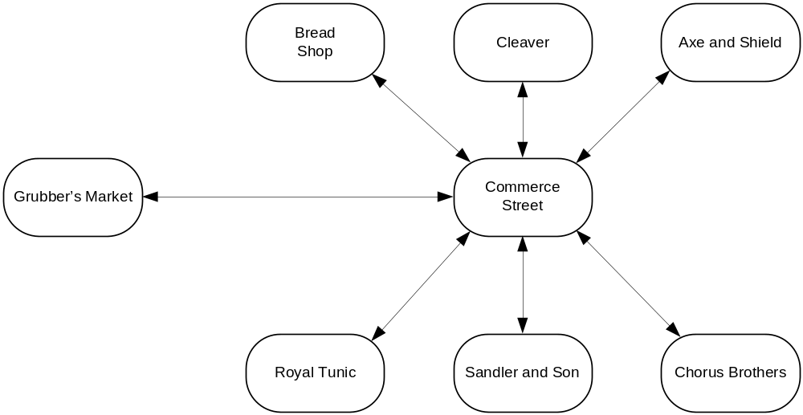

Rundown
Jack has opportunities to talk to people about the environment.
- Baker
- Butcher
- Armory
- Clothier
- Jeweler
- Moneylender

Notes
There isn’t much to this scene other than gathering information. The player can end the scene at anytime by going to find Bobby.

Design
Scene Begins when Jack enters Commerce Street for the first time.
Event [first turn after Jack enters Commerce Street]: You let out a long, shaky breath. You're safe now. Commerce Street is home to a slightly more upscale class of merchant, and business here is not quite as frantic as in Grubber's Market. Transactions tend to be calmer, more deliberate, and involve significantly more money. The It's unlikely that the mercenaries will follow you here; the Lord's Guard will be far less tolerant of a pack of armed bullies menacing the citizens of the upper class, so it's unlikely that the mercenaries will follow you here. And even if they did, there are too many streets and side alleys for them to block off your escape.
Now it's time to pause, catch your breath, and try to figure out why they were after you in the first place.
- Commerce Street
  - Description: Commerce Street runs from Grubber's Market, to the west, to Lord's Market to the east. Raised sidewalks allow pedestrians to avoid the mud, horse dung, and occasional teamster's cart rumbling by. The shops here are actual buildings, spaced evenly along the avenue – on the north side are a bakery, a butcher's shop, and an armory, while a clothier, a jeweler, and a moneylender line the south.
Storefronts for a bakery, a butcher's shop, and an armory line the north side of the street from west to east; they are faced on the opposite side by a clothier, a jeweler, and a moneylender, respectively.
  - Scenery: Outside of Bakery
    - Description: A hanging sign above the door depicts a loaf of bread, and the warm smell of fried dough wafts out from the open door, making your stomach rumble.
Squeezed in between the bakery and the butcher's shop next door is the entrance to a tiny alleyway.
  - Scenery: Outside of Butcher's
    - Description: A brightly painted pig decorates the sign over this shop. The smell of burned sausage masks the darker odor of butchered animals.
Squeezed in between the butcher's shop and the bakery next door is the entrance to a tiny alleyway.
  - Scenery: Outside of Armory
    - Description: The walls over this shop are built of heavy, blackened bricks – a grim exterior to house grim business. The sign over the door is painted with an axe and shield.
  - Scenery: Outside of Clothier
    - Description: A large window, trimmed in fine, dark wood, lets light into the front of the shop. A clothier's dummy dressed in a smartly cut tunic stands in front of a velvet backdrop, advertising the latest fashion to be found inside.
  - Scenery: Outside of Jeweler
    - Description: The sign above this store is painted with a necklace of pearls. The windows are blocked with thick (but decorative) iron bars, and the door sports a heavy lock. An engraved brass plaque reads "Sandler and Son."
  - Scenery: Outside of Moneylender
    - Description: A discreet placard next to the door reads "Chorus Brothers." " The remainder of the windowless storefront is painted blue.
  - Command [going west from Commerce Street]: It would be a good idea to lay low for a while before returning to Grubber's Market.
  - Command [entering any of the stores or going east from Commerce Street while still dressed as a girl]: You'd better take off your "disguise" first – most of the merchants on this street know you as Jack, and would be very confused to see you dressed as a girl.
  - Scenery: Sidewalk
    - Description: The brick sidewalks are equipped with run-off drains to keep the street from flooding during the rains.
  - Scenery: Drains (collectively)
    - Description: The drains lead straight into the sewer system, and are covered with heavy metal grates. The drain on the north side of the street is partially collapsed, and – you know from experience – tends to pool rainwater during a strong storm. The drain on the south side, however, was repaired and cleared, recently.
  - Object: North Drain
    - Description: The grating is rusty and bent. The brickwork above it has partially collapsed, leaving a slight depression in the sidewalk and a gap barely a hand's-breadth high through the drain itself.
    - Command [lift/open grate; enter north drain]: The grating is securely anchored to the brickwork around it. Even if it weren't, you'd never be able to squeeze through the collapsed drain.
  - Object: South Drain
    - Description: The brickwork around this drain is solid and still relatively clean-looking, and the drain channel behind it is wide and dark. More interestingly, the laborers who repaired the drain were apparently a bit careless replacing the grating. The iron brackets holding the grate down weren't mortared in – they're loose in their holes. You could probably lift the whole thing free with a bit of effort.
    - Command [lift/open south drain; enter south drain during scene 2]: There's too many people about right now. Someone is bound to raise a cry if they see you crawling into an open sewer drain on a crowded street in the middle of the day.
  - Object: Tiny Alleyway
    - Description: Almost more of a gutter than an proper alley, barely big enough for you to fit your shoulders through.
    - Command [entering an alley]: By sucking in your gut and turning sideways a bit, you manage to squeeze in between the two buildings.
- Bakery
  - Description: The air is heavy with the warm and slightly damp smell of freshly baked bread, and the wooden counters are piled high with golden loaves, baguettes, and rolls. You can leave the bakery to the south.
  - NPC: Baker
    - Initial Appearance: A man dressed in flour-dusted baker's whites stands behind the counter, watching you expectantly.
    - Description: Germaise the Baker is a tall, thin man from the south. He has a thick accent and likes to stroke his sparse moustaches with his fingertips while he talks – the lower half of his face is almost always covered with a grayish coating of flour. He's a gossip and a shameless flirt, always eyeballing the young ladies who come into his store. It's moments like those that make you grateful for your disguise.
    - Idle Actions (at random):
      - Germaise strokes his moustaches idly.
      - Germaise works on a mound of dough, pounding and pushing it into shape.
      - Germaise rolls several strips of pastry dough into a complicated shape, then slides it onto something that looks like a flat-bladed shovel. Then he turns and shoves the end of the shovel into the glowing mouth of the brick oven behind him.
      - Germaise peers into his oven, checking on the status of his latest batch of rolls.
    - Conversation Table (with Germaise):
Subject | Response
Me | "You live with the Maidens, yes?" he says with a shrug. "I should know more about you?"
Mercenaries | Germaise shakes his head. "When I see steel, I mind my own business."
Bobby | At the mention of Bobby's name, the thin man stiffens. "You see Bobby, you tell him, yes? He comes around here again, he gets the wrong end of this bread knife!"
Teisha | Germaise smiles. "Lovely girl, that Teisha. I send her my best pastries, maybe she gives me a discount, little something for the wife, yes?"
Father | He shrugs. "Theresa's never mentioned him. If he loved your mother, I guess he wasn't so bad, but who knows?"
Mother | "Theresa was talking about you last time she came in here, mentioned your mother. Beautiful woman, very kind, she says. Died when you were very young, yes?" Germaise strokes his moustache solemnly. "Sad, very sad. But without a proper home and husband, I guess it's no surprise."
Maiden House | "Fine women, those. They do good work, taking in orphans like you. I give them discounts," he adds, proudly.
Fossville | Germaise busies himself with a pile of dough, obviously reluctant to be drawn into discussing politics. "Eh, Fossville seems a good enough man. They say he has a temper, but it's not my place to criticize."
Black Gate Estate | "Black Gate Estate, that is where Baron Fossville stays when he is in the city. He throws parties there, places big orders with my shop." He shrugs, rubbing ruefully at his moustache. "What can I say? He is a good customer."
Red Gate Estate | "The old Duke, goddesses keep his soul, stayed at Red State. I brought fresh loaves to his doorstep every morning." Germaise rubs his moustaches sadly. "A good man, he was, and a good lord. I miss him."
Jacob’s Mansion | "Bah!" Germaise waves a hand in the air, flicking a puff of flour from his long fingers. "They hire their own cooks and never buy anything from town. They say they are merchants, but of what? No one knows. I will say it – they are thieves!"
Jacobs | Germaise shakes his head. "Just like his father, that boy is. Thinks he owns everything, and what he doesn't own he takes, and what he can't take he steals. But money always opens doors in this city. Even bad money."
Commerce Street | "You know this street was planned and built by the old lord of Toresal, yes?" Germaise nods and strokes his moustaches. They were to expand it too, open up the block north of here, but then the lord died so unexpectedly. Shame."
Grubber’s Market | "Eh, it's an eyesore, but it keeps the money going round and round," says Germaise. "Half the people in this city couldn't survive without it."
Lord’s Market | "Now that's a lovely place," Germaise says, beaming. "I send a cart out there every day and sell out by the time the bells ring noon. Rich people love their sweets," he laughs.
Lord’s Keep | "Duke Toresal built that keep. Laid the foundation stones with his own two hands." Germaise gets a faraway look in his eye that you usually only see when he talks about his homeland. "Now there was a bright and honorable Lord. He'd have been in line for the throne if he hadn't married below his station. Bah, palace politics. It's no use to try to understand."
Ball | "A ball?" Germaise perks up a bit. "At the Lord's Keep, yes? It's been a long time since we held a big party up there. I’ll have to keep the ovens fired all night and day to keep up with it, you can be sure."
Queen | Germaise makes a short, dismissive noise – "Pfff!" – blowing a cloud of flour from his lips. "The old king valued a pretty face over a sharp mind. I won't say more about that. But now that the king's dead, the kingdom suffers for his choice."
Princess | Germaise smirks. "The Queen’s daughter is a prize that no one wants to win, but to win it means the crown. That is a difficult choice for anyone honorable, yes? I tell you, the throne has dark days ahead."
Spies | "Spies? The King has always employed spies, and after he died the Queen continues to employ them. They keep her appraised of what is happening in her kingdom, and an honest man has nothing to fear from them." He chuckles, "I even used to know some of them, in the old days. They changed them all around since the king's death, though. If any are around here, I wouldn’t know them anymore."
Jail | Germaise shakes a white-dusted finger at you. "A boy like you should stay out of trouble and not think about such a filthy place."
Rooftops | "I better not catch you up there, yes?" he warns. "It's not safe."
Food | A smile spreads across Germaise's flour-streaked face. "What can I interest you in?" he asks. "I have round breads and flat breads, grain breads and white breads, hard breads and soft breads, long loaves and demi-loaves. I make rolls, muffins, pastries, cakes, and the most delicious fried dough you will ever taste. It is no joke to say that my buns are the most firm and delicious in all of Toresal."
Sewers | "The sewerrs are a place to avoid," Germaise warns you. "There are rumors that thieves and scoundrels and worse hide down there, and traverse the city through the tunnels."
Inheritance | Germaise laughs. "Inheritance? Where your fancies take you, boy, I just don't know. Hope that you inherited some wits, so that you can learn a trade and live a good life."
Ascension | "Bah. I do not think of crown politics. I make my voice heard when the time comes, but it is not my voice that decides things. The local regent reports the people's sentiment to the court."
Toresal | "It's a good city to live in," Germaise says, stroking his moustache. "There is respect for the law here, and money to be made if you work hard and stay smart. It cannot compare in beauty to the cities of my beloved southlands," he sighs, " but it lacks in aesthetics, it makes up for in opportunity."
Kingdom | "It's a good time for the kingdom nowadays. The king's law is respected, and there have been no clan wars in over a century." Germaise sighs. "I hope it lasts."
Taxes | "There is no use in complaining about taxes," says Germaise. "But they are not too much of a burden."
Clans | "Don't you read your history?" smirks Germaise. "Before the rule of the southern crown, there were dozens of clans fighting over land, cattle, daughters… it was an era of barbarians, yes? We are better off today, you can be sure." better off now, that’s for sure.
Sea | Germaise gives a theatrical shudder. "Ships. You couldn't get me on a ship at swordpoint, not even the river boats or coastal shuttles. Awful things."
Small Woods | "Those woods are for the lord's private hunting, but the old Duke always kept them open to the public. A romantic place to take your girl, yes?"
Mermaid Fountain | "Ah, yes, I remember that fountain," Germaise says, stroking his moustaches. "A beautiful garden around it, wonderful place to take your sweetheart. It fell into disrepair since the Duke died, more's the shame."
Secret Passage | "Eh? Secret passage?" Germaise looks at you suspiciously. "I don't know anything about it, but it sounds like the kind of thing you shouldn't be messing with – or talking about. Talk like that gets you into trouble with the King's spies, it will."

  - Object: Bread
    - Description: It looks and smells delicious, but right now you need answers more than you need a snack.
    - Command [smelling, eating, tasting, buying, touching, or doing pretty much anything to the bread]: [repeat description, above]
  - Object: Brick Oven
    - Description: Most of the shop's back wall is actually the front of Germaise's huge brick oven. A warm, orange glow and the delicious smells of baking bread drift from its wide opening.
    - Command [doing anything to the oven other than looking at it]: It's behind the counter, and Germaise wouldn't want you messing with it in any case.
- Butcher's Shop
  - Description: Chains of linked sausages and thick, red cuts of meat dangle from hooks in the ceiling, and trays of less identifiable and less pleasant-looking bits sit out on the counters. It's better than some butcheries you've seen, but it's still not your favorite place in the city. You can leave to the south.
  - NPC: Butcher
    - Initial Appearance: Old Man Holstenoffer is leaning over his huge, bloodstained butcher block behind the counter, hacking up some carcass for a customer.
    - Description: Holstenoffer is a squat brick of a man, with a scarred bulldog's face and sailors' tattoos covering his arms from the wrists all the way up to his rolled-up sleeves. He's friendly enough, but he has a tendency to gesticulate with his cleaver in hand, which sometimes makes conversation with him a tense and athletic affair.
    - Event [when player first enters the shop]: He glances over his shoulder as you come in. "Ey, Jack!" he calls. "Long time, no see. Bobby was around this morning, looking for you. Up to something again, eh?" he laughs.
    - Conversation Table (Holstenoffer)
Subject | Response
Me | You look well enough to me. Why? Someone botherin’ ya? Nothin’ me cleaver can take care of I’m sure.
Mercenaries | Holstenoffer's squinty eyes narrow even further when you tell him about the mercenaries scouring Grubber's Market. "Filthy mercs," he growls. "Let 'em try coming up here…they'll find more than some timid stall merchant!" He shakes his cleaver to emphasize the point, forcing you to take a quick step backwards to avoid a deep facial scar.
Bobby | "He said something about waiting for you over by Lord's Market." Holstenoffer waves his cleaver vaguely eastward, flinging a bit of gristle across the room. "You know, you oughtta stick around Bobby more, Jack. He's a big, strong lad. Teach a skinny boy like you to take better care of yourself, eh?"
Teisha | “Ha! Mention that one to the doughboy next door and you’ll see his spirits rise faster than his bread.”
Father | Whaddaya askin’ these questions for Jack? You know I don’t know nothin’ about yer past.
Mother | I heard she was an unlucky soul. Not much else than that.
Maidens | Lovely ladies. I’ve been eying the plump one meself. What’s her name again? Bought time I took in a wife and I ain’t too picky, if ya know what I mean.
Maiden House | It’s a fine place. Keeps most of you urchins out of trouble.
Fossville | “Whack! Dammit Jack, you say that name and every time I near take off a hand. You know I despise the Baron and I don’t think he cares much for Toresal either. If you ask me, the old Lord and him we’re at odds and the Baron won that battle.”
Black Gate Estate | “Would like some tea?” he says in a false matronly voice. “Or maybe some biscuits?” and then a laugh from his belly blows out, “HA!”
Red Gate Estate | “Been collectin’ dust since the old Lord’s death. Even the Baron seems not to care about it for some reason. You’d think he would have sacked the joint by now. Always are rumors about an heir, but that’s unlikely. The old Lord never had a chance with the old battleaxe he was forced to marry by that daft Queen of ours.”
Jacob’s Mansion | Don’t know nothin’ about that house. Built it recently thieves ransoms. Nothing but trouble out there.
Jacobs | Seen him once. Even I won’t mess with him or his boys.
Commerce Street | Love it here. You know I came from farm country and I couldn’t get out fast enough. But choppin’ chicken necks was something I always had a knack for.
Grubber’s Market | Fantastic place. I get my cleavers special made and me leather aprons too. Soaks up the blood better than anything and leaves a perfect shine.
Lord’s Market | “Pah! You wouldn’t catch me over there for a sweet calf and ten fat hens. Nope. Not my kind of place at all. Of course you will find that pal Bobby of yours over there. He probably likes the view, if you know what I mean.” (which makes you turn and blush for some reason)
Lord’s Keep | Never been. I wish is it were occupied by a better soul though. The Baron is as likely to leave a stink as a bad as a herd of pigs.
Ball | (before announcement) “Haven’t had a ball up at the Keep in ages. Not since the old Lord…” and he trails off swearing.  (after announcement) “Got a big order came in this morning. Not sure how I feel, but the Baron paid up front. Business is business and a man has to eat.”
Queen | “Daft old bat. Everything I hear says she can’t rule anything including her temper. What a sorry mess the kingdom is in when she croaks.”
Princess | (before announcement of Ball) “Yikes Jack!”, and throws a handful of salt on the floor to ward bad spirits, “Don’t mention that thing in here. The Queen’s daughter is the blight we’re all going to suffer from eventually. Don’t be in a hurry.”  (after announcement) His shoulders slump and he mutters, “We’re doomed Jack. The Baron is marrying the Princess and he’ll likely maneuver for the crown. We’re doomed.”
Spies | (before Bobby’s death) “The King had quite a network of informers I hear. But that was more than ten years ago. I doubt that network is still around and if its, who they loyal too? The Queen? Not much hope there, is there?”  (after Bobby’s death) “I knew there was something funny about Bobby. Did you know Jack? He had me fooled right good.”
Jail | Sheepishly he says, “Not so bad a place to sleep. Nobody bothers me at least. They’ve seen my cleaver, ya know. But a wife would keep me out of the tavern Jack. Can you put in a good word for me with the maidens?”
Rooftops | “Had to pitch a leaky roof once and I don’t much care for heights. Funny thing is you can jump across all the roofs, even over to the Baron’s pretty little garden if you’re brave. Sat there and had a sandwich myself once.”
Food | “I ain’t got nothin’ cooked, but if you want scraps for stew back at the maiden house, I’m sure I can come up with something. Make sure you let the ladies know where you got it though, right?”
Sewers | “Ingenious little tunnels the old Lord built. I’d be paying a fortune to have my garbage hauled out of town if it weren’t for the sewers.”
Inheritance | (before he knows who you really are)  “Born to an unlucky woman and who knows what man she hooked up with. Jack, you’re just an orphan and a lucky one so far. Don’t be wishin’ for somethin’ that’s just a dream.”  (after)  “Young lady, you still have me flummoxed from showin’ up lookin’ like a girl. I’d swear you were a boy all these years. Now you say you’re the old Lord’s daughter. If it’s true, you have my testimony and you will be recognized. But you’re going to need a lot more help than a fat butcher from the country.”
Ascension | (before)  Tricky rules about the throne. Better askin’ someone else about that.  (after)  “Ha! First you want to be a princess and now you want to be Queen! Ha! Jack, er, Jacqueline, er Jack! Dammit. This whole mess has my head spinnin’. I need to sit down a moment.”
Toresal | Wonderful town until the old Lord died.
Kingdom | Peaceful all my life. Heard about clan wars, but those have long past. Mark my words though, the Baron will ruin everything.
Taxes | “The Baron’s been getting a little greedy lately and he’s not taking care of the land. We’re all going to pay when he’s fully recognized as the ruler of Toresal.”
Clans | “I hear some of the clan life still exists over the mountains. It’s been a long time since the Kingdom has counted clan lines though.”
Sea | “Never been down to the sea, but I’ve sailed on the rivers. I’d like to hitch a ride on a tall ship some day. Wouldn’t that be something?”
Small Woods | Never been up there. I hear it’s pretty and peaceful.
Mermaid Fountain | Don’t know nothin’ about it.
Secret Passage | (before)  “Crazy talkin’ Jack.”  (after)  “You be careful little lady. If you need help, you just let me know and I’ll be right at your side.”

- Armory
  - Description: The tangy smell of oiled steel is nearly overpowering in this small, windowless shop. All of the really interesting weapons – axes, flails, spiked gauntlets and the liklike – are high up on racks on the back wall, well behind the high counter. However, there is a display of assorted knives and daggers sitting out where you can get a close look at them.
  - Object: Dagger Display
    - Description: Over a dozen gleaming blades neatly lined up on a rectangle of dark green velvet; from long, wicked stilettos, to demure little stickers you could hide inside an opera glove, to gigantic cleavers that would make Holstenoffer next door jealous.
  - NPC: Armory Shopkeeper
    - Initial Appearance: Olgan, the proprietor, leans against the counter, watching you intently.
    - Description: Olgan Minor is short but muscular, with a lined face and graying, military-cut hair. He says nothing as you browse his wares, but his eyes seem to bore right into you. You are suddenly certain that he knows you're not really a boy – that he knew it the instant you walked into his shop.
[first time only] You've heard that Olgan Minor is not one to trifle with – and now that you've seen him, you believe it.
    - Conversation Table (Olgan Minor):
Note: Olgan doesn’t like to talk. After three questions, he will refused to answer a question until you leave for awhile and come back later. I’d say at least 5 turns outside his shop before you can go back.
Subject | Response
Me | Minor’s eyes drill into yours and says menacingly, “What exactly about you should I be concerned about?”
Mercenaries | “Are you disparaging my better customer’s young man? I would think you should be more respectful.”
Bobby | “I’m familiar with the young man.”
Teisha | “Do I look like I know everyone in town?”
Father | “No doubt one of the scoundrels from the boats.”
Mother | “I have nothing to say about your mother.”
Maidens | “The maidens and those they care for should be married off or put to work.”
Maiden House | “Idiocy. That building used to be a hotel for travelers. Now it wastes taxes.”
Fossville | “A sight better than the old Lord. Would make a fine King too.”
Black Gate Estate | “Never been.”
Red Gate Estate | “The Baron and the crown need to sell the estate. The old Lord has been dead long enough.”
Jacob’s Mansion | “A fine house.”
Jacobs | “An interesting family.”
Commerce Street | “Tolerable enough. We could lose the bakery and butchery though. People should take care of their own food.”
Grubber’s Market | “Brings in good customers and I trade with one of the men.”
Lord’s Market | “A bunch of useless dandies and spoiled women trolling around a circus. The place offends my very senses.”
Lord’s Keep | “The extravagance is astounding. But the Baron will make good use of it. The old Lord certainly didn’t.”
Ball | (before)  “I have no use for such affairs.”  (after)  “I’d heard about the affair. The only thing notable is the likely engagement of Fossville to the Queen’s daughter. I see no point in the rest of the ceremony.”
Queen | “A useless woman. The old King chose poorly.”
Princess | “Temperamental woman, but resourceful from what I’ve heard.”
Spies | “They’re everywhere. You never know who’s listening to your conversations or your questions.”
Jail | “Never been.”
Rooftops | “I don’t know anything about these buildings.”
Food | “I take care of my own meals, as should everyone.”
Sewers | “More wasted tax dollars.”
Inheritance | (before)  “No one will inherit the old Lord’s estate. The whole thing will be absorbed by the crown.”  (after)  “You’re lucky to live through the night. I seriously doubt you’ll have any chance of being recognized.”
Ascension | “A waste of time. Whoever is the strongest should simply take the crown.”
Toresal | “A backwater town that once thought it was something special. With the old Lord gone, it will return to being nothing but a farm village.”
Kingdom | “Taxes are too high, people are lazy, and women are free to do whatever they wish. Clearly not the way things should be.”
Taxes | “Corruption at its worst. Sanctioned thievery if you ask me.”
Clans | “I’m originally from the Su’ Hart Klan, over the mountains and far to the east. I may yet return someday.”
Sea | “I’m familiar with the eastern sea. I spent many years learning to sail, before taking on the craft of weaponry.”
Small Woods | “More wasted space. That was once excellent farmland.”
Mermaid Fountain | “An extravagance form the old Lord and now filthy and entirely useless.”
Secret Passage | (before)  “I’ve heard rumors.”  (after if you’re alone)  Olgan approaches you slowly and begins to slip a knife out from some hidden place. “You shouldn’t know about such things young lady.”  (after if you’re with Pieter or Germaise)  Olgan’s eyes narrow, but he doesn’t say anything.

- Clothier's (Royal Tunic)
  - Description: The walls are hung with tasteful curtains, and a deep, soft carpet covers the floor. Several clothier's dummies stand about the room, displaying gorgeous formal court apparel for both men and women. The street lies north.
  - Event [when you first enter the shop]: A small bell above the door tinkles as you enter, and a man comes rushing out of the store's back room with a measuring cord in his hands, held up as though ready to begin fitting you immediately. When he sees that you're merely a boy (and by all appearances, not one with much in the way of discretionary income at that), he stops in his tracks and his expression grows distinctly pouty. He manages to keep most of the disappointment out of his voice as he asks, "May I help you?"
  - NPC: Clothier Shopkeeper
    - Initial Appearance: The clothier stands nearby, eyeing you with some distaste.
    - Description: Tall, thin, and impeccably dressed, although his fashion sense seems a bit…decorative, compared to the more austere look preferred by men of Toresal's upper class. His hairline is receding, and what hair he has left is plastered back onto his scalp with fragrant oil. He look as though he'd secretly prefer to wipe things down with a scented handkerchief before touching them; somehow, through good breeding and intestinal fortitude, he manages to soldier on despite not doing so.
- Jeweler (Sandler and Sons)
  - Description: The inside of this store is tasteful but austerely decorated, perhaps to better draw the eye towards the glass display cases in the center of the room, and the king's ransom in jewelry contained therein. You can leave to the north.
  - NPC: The two guards (collectively)
    - Initial Appearance: Two guards stand discreetly near the back of the room.
    - Description: Rudolph and Pieter are good fellows. You've traded friendly words with them in the past, but most of the time they stay quiet to preserve a sense of professionalism. Rudolph gives you a slight smile and nod when you catch his eye.
  - NPC: Rudolph
    - Description: Rudolph is the smarter of the two, and tends to treat you more like an adult.
  - NPC: Pieter
    - Description: Pieter is a bit dim, but loyal to Dame Sandler and tirelessly vigilant. He's nice enough, but he tends to think you're about eight years old, and speaks to you accordingly.
  - NPC: Mrs. Sandler
    - Initial Appearance: Dame Sandler stands near the central display case. A small, dignified smile plays on her lips.
    - Event [when you first enter the jewelry shop]: Dame Sandler is here as usual. Her eyebrows raise slightly as you walk into her store. "Well, hello there, Sire Jack," she says, in her typically smooth (and the slightest bit mocking) tone. "We haven't had the pleasure of your company in a while. You look a bit out of breath – nothing ails you, I hope?"
    - Description: Though in her elder years, Dame Sandler is still a tall and striking woman. Her long, silver hair is pulled back in a complicated bun, and she has a habit of inspecting her merchandise through a monocle on the end of a long, slender, gold-filigreed handle. Sometimes you wonder what she's doing running a shop (even such a relatively high-class one as this); her demeanor is more that of an aristocrat, if not full royalty.
Although you almost never come to her shop (everything in here is too expensive to buy and too well-guarded to nick), for some reason Dame Sandler has always taken a liking to you, and never runs you out when you visit, even when she important customers to tend to. It's more of a bemused curiosity than real affection, but feels good to be on a friendly basis with such an intriguing woman.
- Moneylender (Chorus Brothers)
  - Description: The inside of this shop is dark – dark wood paneling on the walls; deep, wine-dark carpeting on the floor; even a pair of huge armchairs upholstered in rich, dark leather over in one corner. The back half of the room is hidden behind a wall of reinforced wood, with a wide window cut through the center.
  - Event [after entering for the first time]: A moment after you enter, two faces suddenly appear at the window, each seeming to slide smoothly in from either side. They look at you with identical expressions of curiosity and a sort of mild, almost professional contempt.
"Good afternoon," says one.
"May we help you?" asks the other.
  - Object: Window/Counter
    - Description: The window forms a sort of counter, with an ornately scrolled, brass grating that opens to the inside, allowing customers to speak with the proprietors on the other side. In fact, it appears that the only way to get service here is by standing up at the counter, so it's not exactly clear what the fancy chairs are for.
  - NPC: The Chorus Brothers
    - Initial Appearance: The Chorus Brothers hover behind their window, staring at you.
    - Description: It's in some ways fortunate that you're not on a first-name basis with these fellows, because you'd never be able to tell them apart. Their faces are utterly identical, from the tops of their bald, cadaverous heads down to the black, dusty collars of their coats.

Chapter III – Bobby

Map
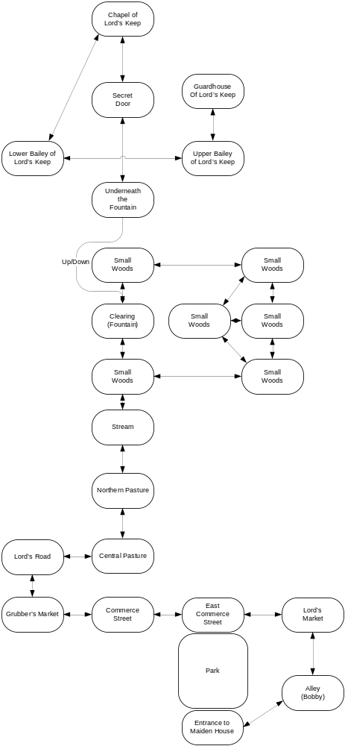

Rundown

Notes

Design
- Lord's Market
  - Description: Lord's Market is the high-class mirror to Grubber's Market: a wide, cobbled square, uncrowded and clean, shaded by tall buildings on either side. Here Toresal's upper crust can hunt for bargains inaccessible to the ordinary rabble. Horses, live cattle, carriages, antiques, custom jewelry, and similarly high-priced goods are available behind the discreet, tasteful storefronts. You can return to Commerce Street to the west, and an alley leads south.
- Back Alley
  - Description: A little-known shortcut between Lord's Market and the less affluent neighborhoods of the city's south end. To the southwest is a street you know well, or you can return to the market square to the north.
  - NPC: Bobby
    - Description: Bobby is a couple of years older than you, a tall, broad-shouldered lad with touseled blonde hair and a rakish grin. He's an orphan, like you, and like you he makes the streets of the city his home and lives by his wits. Unlike you, he doesn't have the safety net of Maiden House to fall back on, but somehow he always seems to do well for himself.
You also happen to think that he's devastatingly handsome, although you would never admit that under the worst torture the King's interrogators could devise. He doesn't even know that you're really a girl, and you're not about to tell him, because if he knew he would certainly stop inviting you along on his exploits.
    - Initial Appearance [the first time you enter the Alley and see Bobby]: At the end of the alley, a group of young urchins – none older than their eighth year – are clustered around something. As you draw closer, you see Bobby crouched in the midst of them. He's holding his arm out, his fist loosely clenched in front of a dirty-cheeked child of six.
"Go on," says Bobby. "Go on, take a look."
The little boy, his eyes wide and solid, reaches out and pries Bobby's fingers open. His hand is empty. The little boy looks dismayed.
"Ah, but what's this?" asks Bobby. And he reaches forward and draws a copper coin from behind the boy's grimy ear. A collective gasp, then squeals of delight from the rest of the children, and the little boy's eyes look ready to fall out of his head.
Bobby presses the coin into the little boy's hand, then passes out more coins to the others. "Here," he says, "keep it safe in your pocket. Spend it on bread, not candy." The children take their prizes and scatter.
Bobby stands and stretches, then he sees you. The corner of his mouth goes up in that lop-sided grin you know so well. "'Lo, Jack," he says. "What's happening?"
    - Initial Appearance [in the alley, after the first time]: Jack leans carelessly against the alley wall, watching you with a slight, wry smile.
    - Event [after you've spent three turns in Bobby's presence]: "Hey listen," says Bobby, "So I've been looking for you, right? I found this new place, big secret, extra tricky. I was thinking of doing a bit of exploring there later tonight. You want to come with?" He smiles that knowing half-smile of his, the one that always means he's about to suggest something that will be very fun, or land you both in a pile of trouble, or – the usual case – both.
What, you're going to say no? Heart thumping a bit harder than you'd like it to, you give an enthusiastic nod.
"Good fellow," says Bobby. "Now, you don't want the Maidens worrying about you, so head on home for now. Once it gets dark, sneak back out and meet me in the Grubber's Market. Right? Good. See you later, Jack." He claps his hand on your shoulder, then turns and strides all grace and overconfidence, out of the alley.
    - Conversation Table (Bobby)
Subject | Response
Me | Bobby very carefully walks a fine line of treating you like a guy friend, but also not offending you because he knows you’re a girl and he also knows you have a bit of a crush on him.
Mercenaries
Bobby
Teisha
Father
Mother
Maidens
Maiden House
Fossville
Black Gate Estate
Red Gate Estate
Jacob’s Mansion
Jacobs
Commerce Street
Grubber’s Market
Lord’s Market
Lord’s Keep
Ball
Queen
Princess
Spies
Jail
Rooftops
Food
Sewers
Inheritance
Ascension
Toresal
Kingdom
Taxes
Clans
Sea
Small Woods
Mermaid Fountain
Secret Passage

- Entrance to Maiden House
  - Description: The alley dead-ends in a small courtyard surrounded by old, run-down buildings.
  - Object: Wooden Door
    - Initial Appearance (from the alley): A battered wooden door provides entrance into the southern building.
    - Initial Appearance (from inside): The front door is [open/cosed].
    - Description (from the alley): There's no sign, but you know it well nonetheless – this is the door to Maiden House, your "home". It is currently [open/closed].
    - Description (from inside, when it's closed): The front door is closed and locked – and it will stay locked until sunup. The Maidens give you much of latitude generally, but curfew is one of the few rules they never, ever bend.
- Lord's Road
  - Description: The wide and well-paved Lord's Road runs from Toresal's North Market Gate straight north to Lord's Keep, a mile or so from the city. To the east are rolling pastures; to the west, broken ground and scrub.
  - Command [go west from Lord's Road]: There's nothing much in that direction but rocks and the occasional thornbushe.
  - Command [go north from Lord's Road]: It's a long hike from here to the Keep, and it's unlikely that the guards at the front gate would let you in.
- Pasture
  - Description: This wide, open field is used by the city for tourneys and other holiday events, or by cattle-sellers driving their livestock to market. Tonight it is empty except for the occasional cow pie. To the north you can see the dark, rough edge of a forest.
  - Event [first time you enter the Pasture]: You feel nervous and exposed out here in all this empty space; you're more used to the narrow alleys and enclosing walls of the city. The urge to hunch over and make yourself small is near-irresistable.
- Stream
  - Description: A small stream bubbles out of the woods and cuts through the pasture's north end. The edge of the forest lies to the north, just across the water. The city is far away to the south.
  - Object: Stream [located at Stream and adjacent Small Woods]
    - Description: The water is clean and clear, rippling over a shallow bed of stones and splashing over the larger rocks. It's only about ten feet wide here; you could probably pick your way across.
    - Command [drink water]: The water is fresh and shockingly cold.
    - Command [swim or dive into stream]: The water is only about shin-deep here.
    - Command [going north from Stream/going south from Small Woods/crossing the stream]: Balancing on the rocks that rise above the rippling current, you nimbly hop across the stream.
- Small Woods
  - Description: You are in the woodlands just southeast of Lord's Keep, following the game trails that wind their way through stands of pale birch and black, spruce. There is just enough moonlight trickling through the upper branches to see your way by. [if the player is adjacent to the Stream, add the following] A bubbling stream flows out of the forest to the south, into an open pasture.
- Clearing
  - Description: The woods open out here in a small, moonlit clearing.
  - Object: The Fountain
    - Initial Appearance: The ruins of an old pavilion lie here, pale pavestones poking up like bones from the grass. In the center of it stands a crumbling fountain.
    - Description: The fountain is shaped like a large bowl, topped with a classical-style statue of Brigid pouring water from an urn. Of course, the fountain is dry now, its stone cracked, the bowl filled with bird droppings and dead leaves. But at one time it must have been very beautiful.
    - Event [when you arrive at the fountain with Bobby]: "Here we are." Bobby jumps up into the bowl of the fountain, dried leaves crackling beneath his boots. Then he reaches around the statue of Brigid as though trying to embrace her. His hands fumble at something on the underside of the urn.
Suddenly there is a deep, solid thunk, and a scraping sound. And part of the base of the statue moves.
Bobby hops down and pushes against the statue's base. A rectangle of stone about two feet square swings inward on protesting hinges. The space behind it is utterly black, and a cold, draft of damp-smelling air rises out of it.
"It runs all the way to Lord's Keep, coming up under the chapel," says Bobby as he brushes off his hands. "I don't think anyone knows about it. Maybe Lord Toresal did, but now that he's dead it's basically unknown. It's not been used for decades, I'd guess. Well anyway, until now, that is."
He holds out his hand. His lop-sided smile is absolutely charming. "You coming?"
- Underneath the Fountain
  - Description: Steps lead up to the fountain above you, and a long, low-ceilinged tunnel leads north into the gloom. The stones of the walls and floor are old, damp, and spotted with some sort of fungus. The air has a wet, sour smell to it.
- Secret Door
  - Description: The tunnel ends here at a blank, stone wall.
  - Description when the secret door is open: The wall at the north end of the tunnel has swung open, revealing a secret entrance to the castle.
  - Event [when you arrive at the Secret Door with Bobby]: Bobby brushes his fingertips across the stonework and quickly finds a loose brick. He pulls it free, revealing a rough, rectangular hole.
You wonder how many times Bobby has been down here. He seems to exude an easy confidence as he reaches into the hole and releases a hidden latch.
Suddenly, the wall swings away, revealing shadowed sp aces beyond.
  - Command [closing the secret door]: Better let Bobby handle the secret door. If you close it, you'll never figure out how to get it open again.
- Chapel
  - Event [first time you enter the room, from the secret door]: A prickle runs down your back as you step into the dim alcove. Are you really sneaking into the Lord's Keep? You're not even sure what the punishment for that is… something a lot worse than a few days in jail, certainly.
  - Description: [round chamber – wood paneled walls in warm colors, inlaid woodcuts of the Goddesses on the walls. Dimly lit by votive candles.]
- Lower Bailey
  - Description: A thick wedge of shadow covers the base of the Keep's outer wall, providing a relatively safe place to hide. The rest of the courtyard is flooded with moonlight, and bored-looking guards stroll back and forth over the gravel.
  - Object: Stone Stairs
    - Initial Appearance: Steep stone steps climb up to the top of the wall. You could make a dash up them, if you timed it right.
- Upper Bailey
  - Description: At the top of the wall you can lean out over the parapets and take in all the lands surrounding Toresal. It's a nice view, but torches set every few yards along the wall make this a dangerous spot to linger in. A stairway leads down into the courtyard below, and a dark archway opens to the north.
- Guardhouse
  - Description: A narrow antechamber, with an open archway to the south and an iron-reinforced door to the north. Arrow slits to either side lend the door an important and dangerous air.
[notes – player can listen at the arrow slits and hear guards talking. Actually entering the room leads to end of game.]

Chapter IV – Maiden House

Map
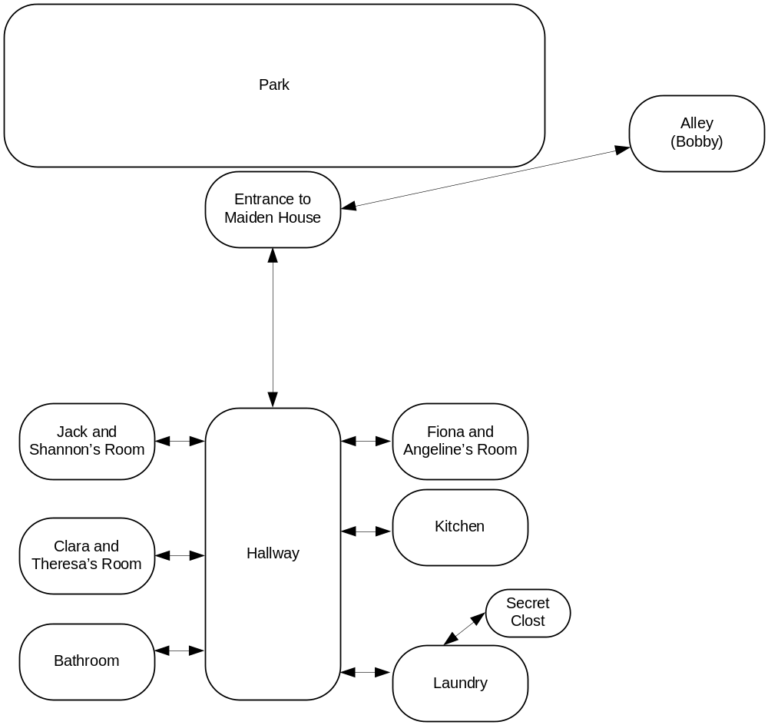

Rundown

Notes
Front – dormitory for widows. Mostly older (30s) women, some nice, some not-so.
The secret closet is for hiding in when the guards eventually search Maiden House.

Design
- Hallway
  - Description: The main hallway runs north-south through the center of Maiden House, with several doors leading to rooms on either side.
To the southeast and southwest are the laundry and middens, respectively; directly to either side, east and west, are the kitchens and Clara and Theresa's room. To the northeast is Fiona and Angelina's room, and to the northwest is the room you share with Shannon.
  - Event [first time you enter MH, before the room description]: You slip quietly through the front door, into the familiar smells of cooking grease and laundry soap; the familiar sight of shabby, warped floorboards lit by dim, flickering tallow lamps. It's nothing fancy, but it's home, and you're familiar enough with the plight of most of Toresal's orphans to know that you're lucky to have it.
  - NPC: Theresa
[note – Maybe Theresa runs the place? She could patrol the hall, meaning Clara has to help you escape through the bathroom window.]
- Jack and Shannon's Room
  - Description: Your room is small and functional, like the other dormitories. Two cots with thin blankets, two small trunks, a rough wooden chair and a small writing table fill most of the available space.
  - Event [when you first enter, after the room description]: Besides you, the room is empty. Shannon must have laundry duty tonight.
- Fiona and Angelina's Room
  - Description: Hundreds of bright-colored paper flowers cover both cots, the table, and most of the floor; the effect is festive but somewhat claustrophobic.
- Clara and Theresa's Room
  - Description: Several of Theresa's sketches are tacked up, in an attempt to add a bit of decoration to the austere walls. Clara's side of the room is still somewhat bare.
- Kitchen
  - Description: A long, low-ceilinged room with a fire pit at one end for cooking, a basin at the other end for washing, and rows upon rows of pots and pans hanging from the rafters.
  - Object: Pots and Pans
    - Description: Dozens of them, and you are familiar with each and every one. Scullery duty is not exactly your favorite day of the week.
  - NPC: Angelina
- Middens
  - Description: Not much more than a narrow closet, with a hole in the floor and a bench over it. At least it's more private than an alley.
  - Object: Window
    - Initial Appearance: A narrow window over the bench provides some ventilation.
- Laundry
  - Description: Moisture trickles down the walls. The air is filled with steam and the sharp stink of lye soap, and puddles of grayish water splash underfoot. Though not quite so hot nor as dirty as the kitchens, it is uncomfortable, and it's not uncommon for girls to find somewhere else to be when laundry duty comes up.
  - Object: Washtub
  - NPC: Shannon

Chapter V – Captured

Map
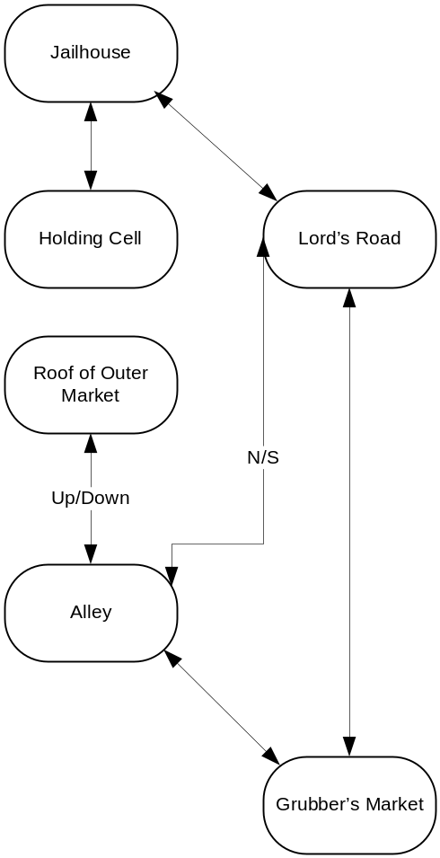

Rundown

Notes

Design
- Jailhouse
- Holding Cell
  - Description: You are in a dank, foul-smelling cell. Besides a couple of ragged burlap blankets and a few lumps of filthy straw, the room is empty.
NPC: Jacobs
NPC: Olmer
NPC: Darrens
Event: getting out of the cell –
You're in a cell with Jacobs. Olmer and Darrens
Jacobs will get you out, but will turn you in. You have to get Olmer and Darrens out as well, and go into the sewers with them.
Maybe Jacobs has a pick?
Event: sneaking out, down Lord's Road, through the markets, into the Sewers.

Chapter VI – Underground

Map
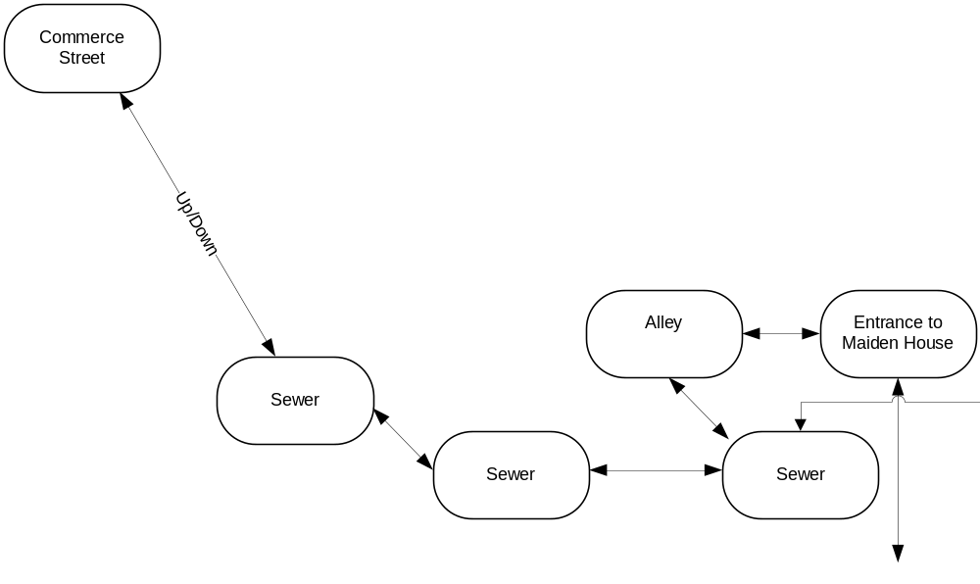

Rundown

Notes
Sewers come up into Alley outside Maiden House.
If you go without Olmer & Darrens, you'll get totally lost.

Design

Chapter VII – Black Gate Estate

Map I - Rooftops
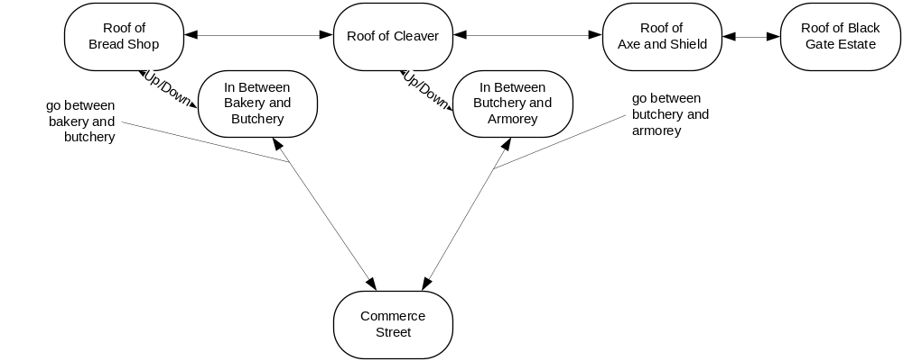

Map II – Black Gate Estate
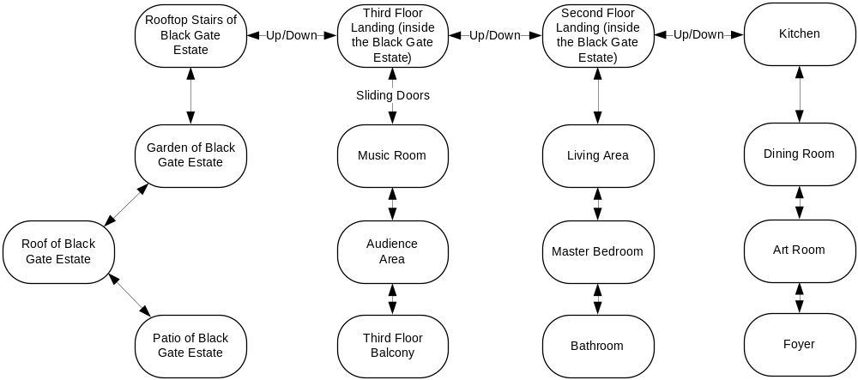

Rundown

Notes
The roof is flat, with a patio, a rooftop garden, and stairs that lead down from the roof.
Empty except for servants… they'll kick you out if they catch you. The letter is in a library (where bathroom is).
There's a new section of the bookshelves, different books (from Red Gate Estate), letter is in one of them.
Discover information about Baron Fossville – how close he is to the throne, learn that he's a bad guy.
Maiden House gets closed down.
First floor is off-limits – too many servants.

Design
In Alley
Description: Rough brick and mortar catches your clothes. Weeds and gravel underfoot. The street lies south. The walls are close enough together that you could climb up by wedging your feet to either side.
Command [climb up walls]: Wedging your shoulders and feet against the walls, you push yourself up.
Rooftops
Description: Shingles, sloped roof with a widow's walk on top. Perhaps jump across several rooftops before you get to Black Gate Estate.
Roof of Black Gate Estate
Description:

Chapter VIII – Maiden House II

Map

Rundown

Notes
This is when the guards search Maiden House.

Design

Chapter IX – Red Gate Estate

Map
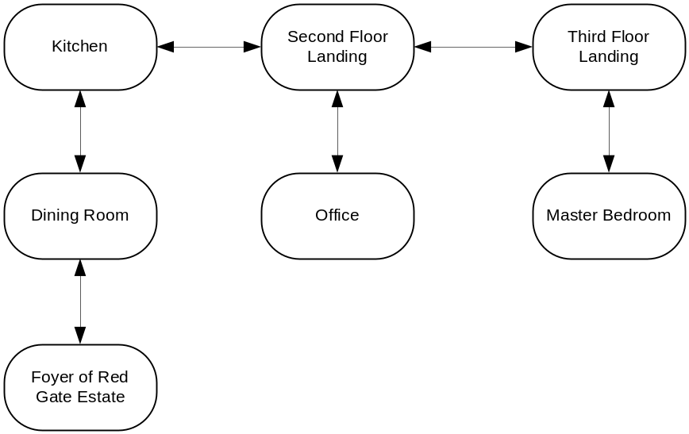

Rundown

Notes
Dusty, furniture covered with sheets. You find a bath. (Bathroom off the Master Bedroom).
This is you – this is your family.
Bathroom scene – no longer a boy – turning into a princess. Baptism. You've never been really clean before.
Detail about father. Discover heritage.

Design

Chapter X – Pieter

Map
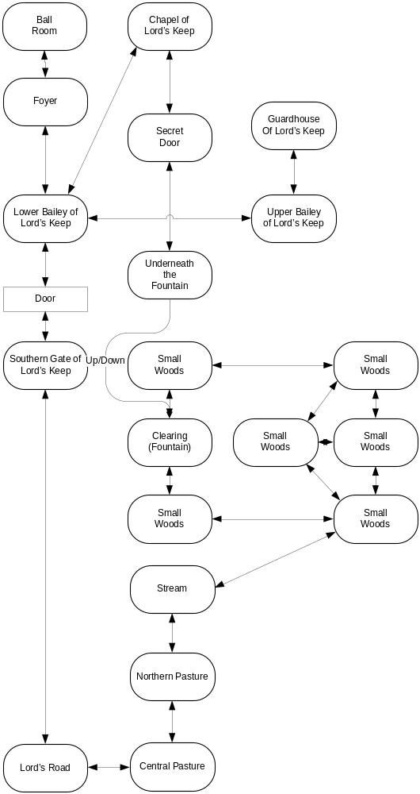

Rundown

Notes
At the ball – meet people. You are "presenting" yourself… you now have supporters and enemies. Some time spent with dialogue.

Design

Chapter XI – Mercenaries

Map
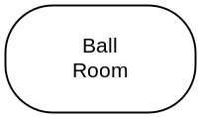

Rundown

Notes

Meet and Greet
- Jacob’s (the father) and his wife. Gruff merchant, known for taking advantage of everyone.
- The Princess is approachable and very confrontational.
- The Queen is present, but unapproachable. But she sees you and knows you (you think).
- The Duke and Duchess of Inhyron (Seven Lakes). Very formal, very affluent, and also very honorable. Liked Jack’s father very much.
- The Baron and Baroness of Amhyron (western Seven Lakes). Less formal, beholden to the Inhyron Duchy.
- The Earl of Bresa (The Kozar Delta). Boastful merchant with a purchased title. Has no power, because he throws money around no matter how people treat him.
- Prince of Gravesal, a set of lands in the northeast. A devastatingly handsome prince of distant royal blood, not obviously interested in crown politics. Very sardonic personality.

Design

Chapter XII – The Baron

Map
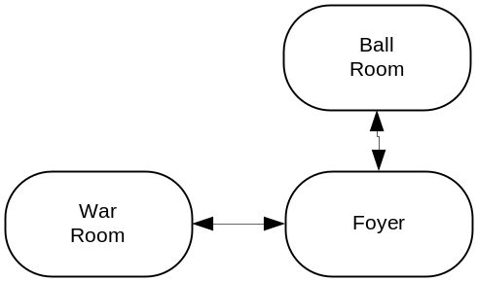

Rundown

Notes

Design

Chapter XIII – The War Room

Map
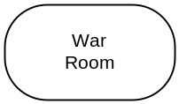

Rundown

Notes

Design

Chapter VIX – The Princess

Map

Rundown

Notes

Design

